Project Report 

|  |  |
| --- | --- |
| **Product Name** | Applied Degree in Software Engineering (BDSE) |
| **Qualification Name** | Applied Degree in Software Engineering |
| **Product Name** | Programming Foundations |
| **Module Name (BDSE)** | **Programming Foundations** |

|  |  |  |  |  |
| --- | --- | --- | --- | --- |
| Learner name |  | | Assessor name |  |
| Syavira Rizki Ariani |  | |  |  |
| **Date issued** | **Completion date** | | | **Submitted on** |
| 16/1/2023 | 19/1/2023 | | | 19/1/2023 |
|  |  | | |  |
| **Project title** | | Development of Judo Training Cost Calculator | | |

|  |
| --- |
| **Learner Declaration** |
| I certify that the work submitted for this assignment is my own and research sources are fully acknowledged.  Student signature: Date: |

* 1. Introduction…………………….....................................................................3-14
  2. Types of Programming paradigms……………………………………………………………………..14-19
  3. Programming paradigms use to make a project & example……………………………….19-21

2.1 5 features available to use Eclipse IDE to build the Application & example…………..21-24

2.2 Explain about using IDE and without IDE……………………………………………………………..25-39

3.1 Architecture of the system along with module and its components description ……………………………………………………………………………………………………………………………………40-41

3.2 Define algorithm and outline the process building an application………………………………………………………………………………………………………….........41-46

3.3 Steps taken from writing code execution………………………………………………………………47-51

4.1 develop a fully object oriented solution by providing source code of implementation…………………………………………………………………………………………………………….52-65

4.2 Algorithm translated to equivalent code…………………………………………………………………65-77

5.1 Explanation of debugging features available in chosen IDE……………………………….……78-79

5.2 Example of Steps debugging & screen captures………………………………………………………………….79-84

6.1 Managing the development process……………………………………………………………………………………85-93

6.2 Screen Capture of the various use of IDE during development process ………………………………93-95

7.1 List coding standards ………………………………………………………………………………………………………....96-98

References……………….………………………………………………………………………………………………………………99

**Task 1**

1.1

My name is Syavira Rizki Ariani,I just started a new role as a Junior Software Developer at a AQ Digital Solutions (AQDS). AQDS are independent software develop team as a software solution of all sizes and variety industries. And I am so excited to begin this new role and contribute the team. Cause This allows us to be flexible and adaptable in our approach to software development and solve the program has been requested by the client itself.

AQDS (AQ Digital Solutions) company has been approached by a small (Local Company) it is North Sussex Judo that specializes which providing training sessions to members of the local community. Regardless from of their level of experience.they cater to people of all ages and skill levels (expert to beginner), and committed to provide high quality judo training for the people who has interested for it. North Sussex Judo Company, their has make a strong to built a local community which is the North Sussex Judo it self has a loyal for the costumer base of people who had interested about the judo and always for comitte to improve their skills and abilities.

As a Result from approach the North Sussex Judo And we are as a junior software developer from AQDS so interested to potentially work with north sussex judo and making a solutions and their goals by developing costumized software solutions. North Sussex Judo has been requested program that calculate the cost of training fees for their athletes each months.. And North Sussex Judo currently have six atheletes enrolled on their training program, but they would like the ability to register more. For making an easier in this program. I will make the application for the athletes or the members that comfortable to access it, and will help for join the training that they want it. And also need to design interface more like understable and make everybody understood for that. Before to begin with the making program, we must discussed about to the client what are they need.

In this project after we discussed, we found a difficulities maybe as a we don’t know who are going and how many to sign the training later,because it is unpredictable,and much more people who joined, and we need and give some effort to reach out the goal which is I mention to automate registration and training cost calculation. For reach out this goal we have few points requirements must be added to this project.

1. functional requirements : are the requirements given by the client as North Sussex Judo. A few features do the client want to be use in a software.They are also called system behaviour.

* The data input for this program included the athlete’s name, training plan, current weight in kilograms,competition weight category, the number of competitions entered this month and the number of hours of private coaching.
* Calculation method for determine the total costing of training and competitions for the each months could depend of the specific price and billing. We need it to accurately calculate the total cost.
* And the program should also be able to give this following output:
* The athlete’s name
* An itemized list of all costs for the month
* The total cost of training and competitions for the month
* How their current weight compares to their competition weight category.

This information needed to the user through some form of the user interface.

1. Business Requirements : Basically for the Client Company. And get benefits in this software/program, and make automate the registration of process,reduce time, registrer more atheletes efficiently, etc.

* This Program make able to calculate the cost of training fees for atheletes each month.
* Make a simple program to use and understanding.
* The AQDS environments will to attend and code standards.
* This program can be flexible to use by user/people of all ages,skills, and making the experience for expert to beginner.
* Easy to handle any variety of different training plans and pricing structures.

TRAINING PLAN

|  |  |
| --- | --- |
| **Training Plan – Prices ($USD)** | |
| Beginner (2 sessions per week) – weekly fee | $25.00 |
| Intermediate (3 sessions per week) – weekly fee | $30.00 |
| Elite (5 sessions per week) – weekly fee | $35.00 |
| Private tuition – per hour | $9.00 |
| Competition entry fee – per competition | $22.00 |

|  |  |  |
| --- | --- | --- |
|  | **Weight Categories** | |
| Categories |  | Upper Weight Limit(Kg) |
| Heavyweight |  | Unlimited(over 100) |
| Light-Heavyweight |  | 100 |
| Middleweight |  | 90 |
| Light-Middleweight |  | 81 |
| Lightweight |  | 73 |
| Flyweight |  | 66 |

* Easy to handle multiple athletes at once
* Make easier to produce a report or invoice detailing for the cost each athlete.
* Easy to handle any additional fees, such as a private coaching fees.
* This program will be able to store data for each athelete, including their name, planning,and weight.

1. Non-functional Requirements are basically system properties. Like what abilities does the software have. The Software must be :

* Performace : this program can be easy to handle a large number of each atheletes and calculation without performance issues.
* Scalability : this program can be able to handle escalating the number of atheletes and compute as the company grows.
* Security : This program must store and handle which is sensitive personal and financial data in a secure manner in accordance with relevant laws.
* Usability : This program can be easy to use and understand for users/each atheletes of all ages and levels.
* Realibilty : this program must be able to handle unpredictable/error input or situations without crashing.

1. Environment requirements :

* Software: Determine the requirements and conditions of the software resources that must be installed on the computer to ensure optimal operation of the application.
* Application Software: This is the most common type of computer software and can be defined as an end-user program that helps in carrying out a project or achieving a desired result. The end user is the person who actually uses the product/application. Some examples of software include word processing programs such as Microsoft Word, etc. has many options and users can choose the one that suits their needs, budget and expectations.
* System software: Helps the user, computer or mobile device and the application to work seamlessly. This makes system software essential for the operation of any application software as well as the entire computer system. software: software designed for end users and system software for mobile computing devices, programming is a computer programmer and programmer who writes code. It's useful to think of these programs as a kind of translator. They take programming languages ​​like Python, C++, etc. and translate them into something a computer can understand.
* Driver Software: This software is often considered as system software. The driver software controls and manages devices connected to the computer. These drivers allow the device to perform necessary functions.

design tools: ms Powerpoint/doc.

MS PowerPoint is a program included in the series of Microsoft Office. It is used to create presentations for personal and professional purposes. There are several features in MS PowerPoint that can customize and enhance a presentation: ·

* Chart Layout There are several options and layouts on which the presentation is based. This option is available in the home section and one of the many layout options offered can be selected. The following figure shows the different slide options available for use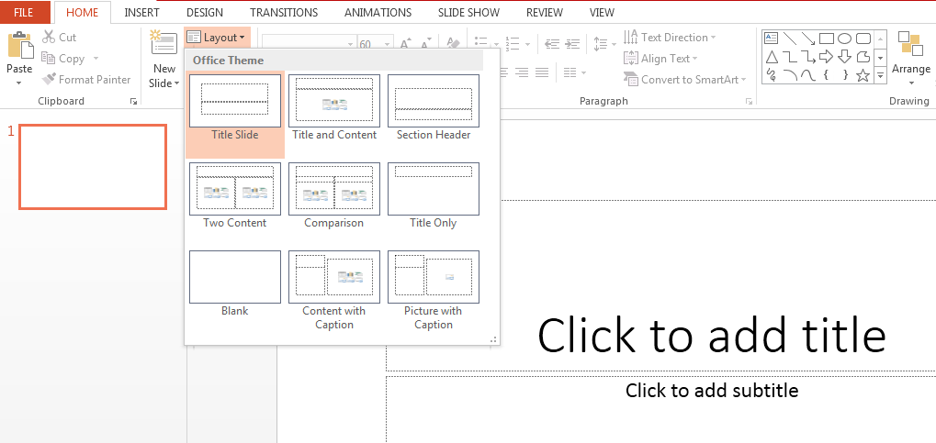
* Import - Images, Video, Audio and more. Under the Input category, there are several options for choosing which function to include in the presentation. This can include images, audio, video, header, footer, icons, shapes and more. The following image shows the functions that can be included

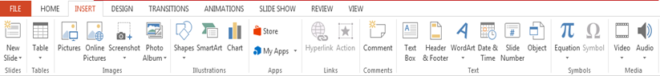

* Slide design MS PowerPoint has different themes that allow you to add background colors and themes or texts to the slide. This makes the show more colorful and attracts the attention of the audience. This feature can be added through the "Design" category mentioned on the home page of MS PowerPoint. Although there are already existing design patterns, if one wants to add a new texture or color.

there is also an option to customize the design. Moreover, slide designs can also be downloaded online. To design slides, see below :

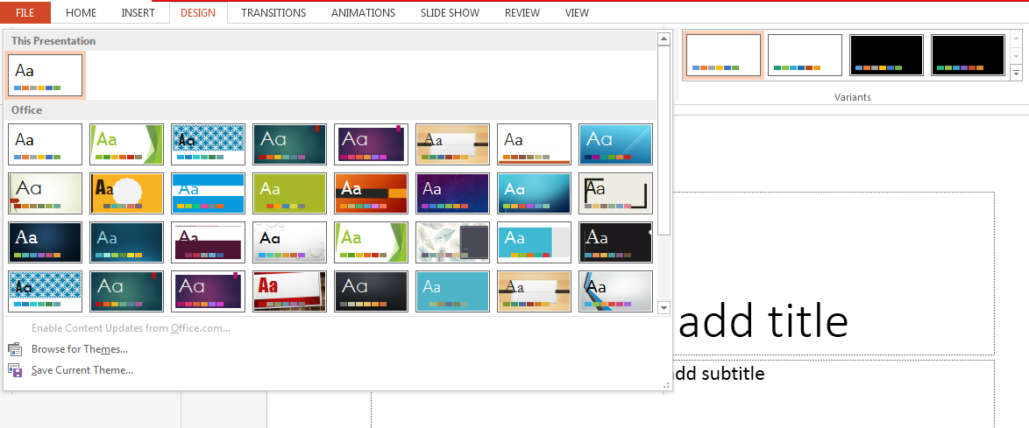

* Animations During a slide show, slides appear one after the other on the screen. If you want to add some animations to your slide presentation, you can refer to the Animations category. Different styles of animations available in PowerPoint, Apart from all these options; Font size, font style, font color, word art, date and time, etc. can also be added to PPT

Microsoft word :

Microsoft word is a word processor software developed by Microsoft in 1983. It is the most commonly used word processor software. It is used to create professional quality documents, letters, reports, resumes, etc and also allows you to edit or modify your new or existing document. The file saved in Ms Word has .docx extension. It is a component of the Microsoft Office suite, but we can buy it separately and is available for both Windows and macOS. We can using a few features to perform different types of operations on your documents, like we can create, delete, style, modify, or view the content of your document :

**1. File**

It contains options related to the file, like New(used to create a new document), Open(used to open an existing document), Save(used to save document), Save As(used to save documents), History, Print,  Share, Export, Info, etc.

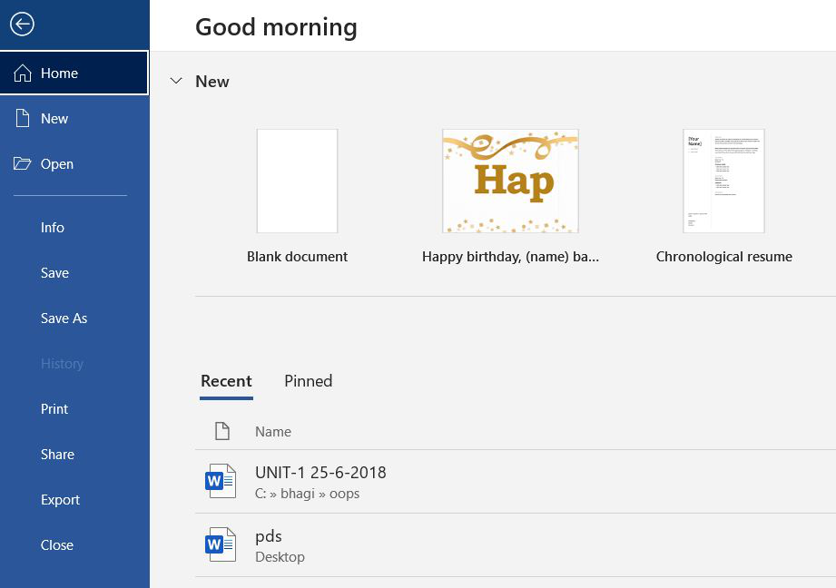

**2. Home**

It is the default tab of Ms Word and it is generally divided into five groups, i.e., Clipboard, Font, Paragraph, Style and Editing. It allows you to select the color, font, emphasis, bullets, position of your text. It also contains options like cut, copy, and paste. After selecting the home tab you will get below options:

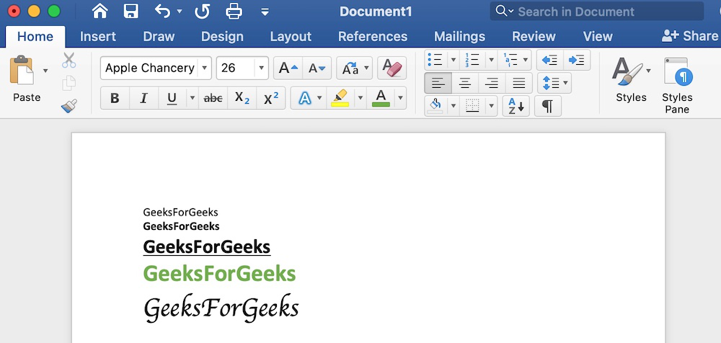

**3. Insert**

It is the second tab present on the menu bar or ribbon. It contains various items that you may want to insert into a Microsoft word. It includes options like tables, word art, hyperlinks, symbols, charts, signature line, date and time, shapes, header, footer, text boxes, links, boxes, equations, etc., as shown in the below image:

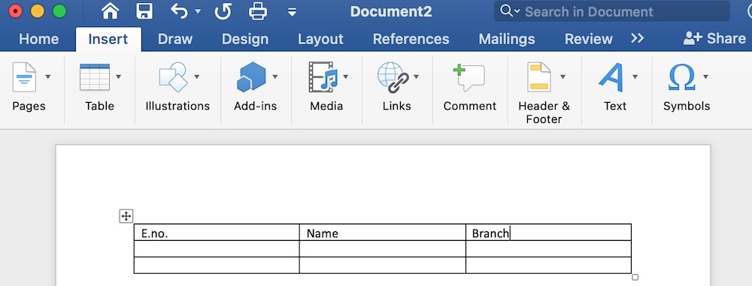

**4. Design**

It is the fourth tab present in the menu bar or ribbon. The design tab contains document designs that you can select, such as documents with centered titles, offset headings, left-justified text, page borders, watermarks, page color, etc., as shown in the below image:

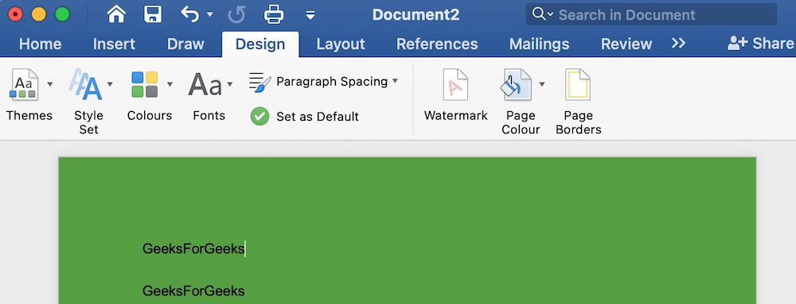

**5. Layout**

It is the fifth tab present on the menu bar or ribbon. It holds all the options that allow you to arrange your Microsoft Word document pages just the way you want them. It includes options like set margins, display line numbers, set paragraph indentation, and lines apply themes, control page orientation and size, line breaks, etc., as shown in the below image:

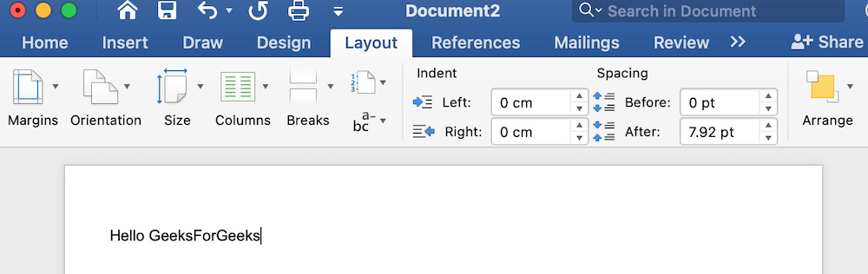

**6.References**

It is the sixth tab present in the menu bar or ribbon. The references tab lets you add references to a document, then create a bibliography at the end of the text. The references are generally stored in a master list, which is used to add references to further documents. It includes options like, Table of Contents, Footnotes, Citations & Bibliography, Captions, Index, Table of Authorities, smart look, etc. After selecting References tab, you will get the below options:

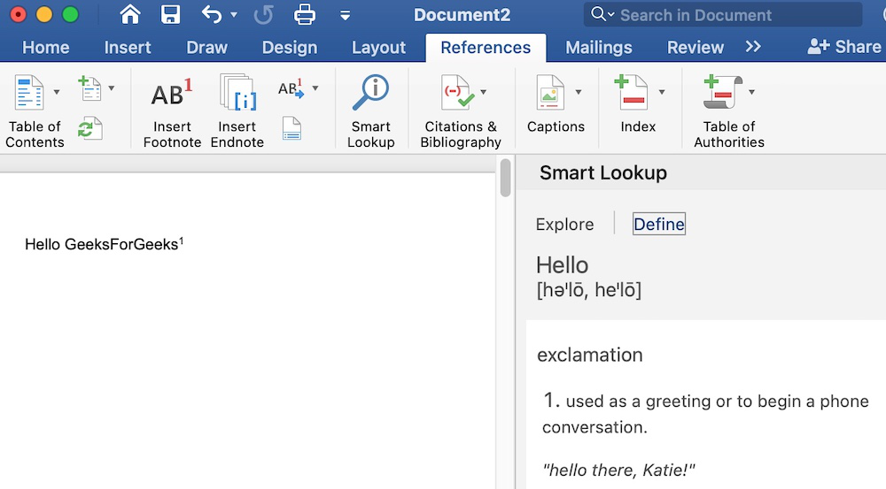

IDE: Eclipse What is an IDE? :

IDEs are software development tools that developers use to simplify their programming and design experience. IDEs have a built-in user interface that brings together everything a developer needs to write easily. The best IDEs have features that allow developers to write and edit code editors, debug code with a debugger, compile code with a code compiler, and automate some software development projects.

Standard IDE Features:

• Text Editor: Almost all IDEs offer a text editor designed specifically for writing and modifying source code.

• Debugger: Debugging tools help developers identify and fix errors in source code.

• Compiler: The compiler feature in an IDE helps programmers translate programming languages ​​into machine-readable languages ​​such as binary code.

• Code Completion: This feature helps developers intelligently and automatically complete common code and components. This process helps the developers to save time and reduce errors caused by errors.

For example, the best IDE is Eclipse:

¬ Eclipse is a cross-platform tool with a powerful user interface that supports drag and drop.

¬ Eclipse IDE is also loaded with some important features like static analyzers, debugging and profiling features.

¬ Eclipse is friendly to enterprise development, allowing developers to easily work on scalable, open source software.

¬ Eclipse is best associated with Java, it also supports multiple programming languages. In addition, users can add their favorite plugins to the IDE to help with software development.

Language Ability: OOPS Computers are powerful machines. With a computer we can calculate numbers very quickly and create many amazing applications for use. But to use this power, we need to communicate with the computer using something less painful than manually typing ones and zeros. OOP aims to solve this problem by allowing developers to break down elements into smaller, more manageable objects that can be developed and tested separately. This not only simplifies the development process but also adds scalability to the project

Object Oriented Programming Language As we know:

Java

Java is the leading OOP language OOP Java is one of the most used and requested languages. Java's motto is "write once, run anywhere," and this is reflected in the number of platforms it runs on. We can use Java for software, games and support etc. Object-oriented programming in Java shares the same fundamentals as other OOP languages.

Python

Python is an object-oriented programming language with strong roots in machine learning, artificial intelligence, and data science. It is also a versatile and beginner-friendly language with a syntax often compared to English. In Python, OOP greatly contributes to code reuse. This allows developers to maintain and manage code in less time.

C++

C++ is a superset of C, which means it has the speed of C, but with additional functionality. C++ is known to be a compiled, reliable and productive language. It is even used to create compilers and interpreters for other languages. Object-oriented programming in C++ facilitates a smoother and more efficient development process.

Ruby

Ruby is another OOP language designed for simplicity. That being said, Ruby is an incredibly powerful language. The creator of the ruby, Yukihiro "Matz" Matsumoto, said, "The ruby ​​looks very simple, but inside it is very complex, just like our human body." It is commonly used with Ruby on Rails to create dynamic applications.

C#

C# is an object-oriented programming language developed by Microsoft. It is designed to enhance existing concepts in C. C# supports the Microsoft .NET framework along with many web applications, games, desktop applications, and mobile applications. Some of the most common OOP concepts in C# are encapsulation, inheritance, and polymorphism.

PHP

PHP is an OOP language that is considered a server-side scripting language. PHP can be embedded in HTML and used to create dynamic websites. PHP, which stands for Hypertext Preprocessor, is also one of the easiest programming languages ​​to learn. But note that PHP does not support all object-oriented features such as multiple inheritance.

TypeScript

TypeScript is a JavaScript superset with static typing. It is designed to help developers launch scalable projects and web applications. Because TypeScript builds on the concepts of JavaScript, another language that supports OOP functionality, it can be said that TypeScript is somewhat object-oriented.

JavaScript

JavaScript is object-oriented, but it is not a class-based language like most OOP languages. This can be confusing because classes are supposed to be one of the main features of OOP. However, there is no standard specification that a language must be OOP, as long as it uses an object-oriented model and supports modularity and code reuse. According to most developers, JavaScript meets these criteria. Technically, JavaScript is a prototyping language, which is an OOP style. Instead of using classes to define objects, object-oriented programming in JavaScript allows you to use and reuse constructor functions.

Hardware : machine The most common set of requirements defined by any operating system/software aplplication is the physical computer resources,also known as hardware, a hardware requirements list of often accompanied by a hardware compability list, especially in case of operating systems.

Architecture All computer operating systems are designed for a particular computer architecture. Most software applications are limited to particular operating systems running on particular architectures. Although architecture-independent operating systems and applications exist, most need to be recompiled to run on a new architecture. See also a list of common operating systems and their supporting architectures.

Computer Power Central

Processing Unit (CPU) power is the main system requirement for any software. Most software running on the x86 architecture defines processing power as the model and clock speed of the CPU. Many other CPU characteristics that affect speed and performance, such as bus speed, cache memory, and MIPS, are often overlooked. This definition of performance is often inaccurate, as AMD Athlon and Intel Pentium CPUs often have different transfer speeds at similar speeds. Intel Pentium CPUs are very popular and are often mentioned in this category.

memories. All software, when it runs, resides in the computer's random access memory (RAM).

Storage requirements are determined by taking into account the needs of the application, operating system, software and support files, and other running processes. The definition of this requirement also takes into account the optimal performance of other related software running on a multi-threaded computer system.

second warehouse. Data storage device requirements vary, depending on the size of software installation, temporary files created and maintained while installing or running the software, and possible use of swap space (if RAM is insufficient).

Display adapter. Software requiring a better than average computer graphics display, like graphics editors and high-end games, often define high-end display adapters in the system requirements. Peripherals Some software applications need to make extensive and/or special use of some peripherals, demanding the higher performance or functionality of such peripherals. Such peripherals include CD-ROM drives, keyboards, pointing devices, network devices, etc.

**1.2**

Object-oriented programming (OOP) is a computer programming model that organizes software design around data, or objects, rather than functions and logic. An object can be defined as a data field that has unique attributes and behavior. (Gillis, n.d.)

A. Procedural Programming Paradigm

Procedural programming is a programming paradigm, derived from imperative programming, based on the concept of the procedure call. Procedures (a type of routine or subroutine) simply contain a series of computational steps to be carried out. Any given procedure might be called at any point during a program's execution, including by other procedures or itself. (Lavender, 2022‎ ). This paradigm emphasizes on procedure in terms of under lying machine model. There is no difference in between procedural and imperative approach. It has the ability to reuse the code and it was boon at that time when it was in use because of its reusability.

|  |
| --- |
| Advantages of procedural programming : |
| * The procedural programming languanges are relatively much easier to learn as first programming language for the beginner |
| * The straight forward program organization makes it deal choice as general purpose language |
| * The procedural programming such as C language is still being used for many application |
| * The C language has extensive library of function suitable for various application. |
| * The use of standard library functions bring down significant reduction in the overall development cost and time. |
| * The concept of pointers in the procedural programming C language allows level memory operations |

|  |
| --- |
| Disadventages of procedural programming : |
|  |
| * The procedural programming not suitable for large and complex software project |
| * It is difficult to represent the real world objects realistically in the procedural programming |
| * It is difficult to protect the data from inadvertent change since most data is generally global leading to the problem of spaghetti code |
| * The software maintenance is relatively difficult for a procedural programming software |
| * For procedural programming paradigm, the function most important component of the program and the data doesn’t get the due attention. |
|  |

Example of procedural programming paradigm :

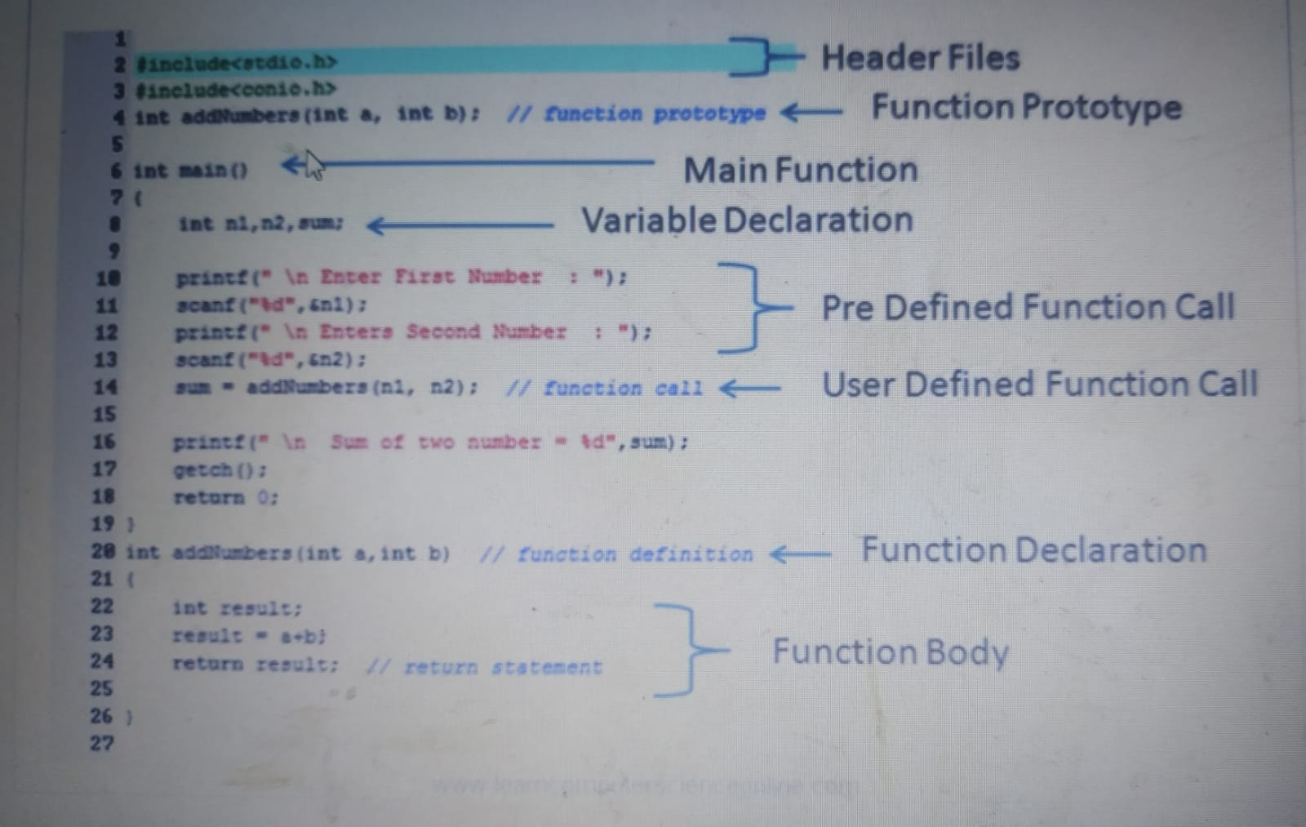

B. Object Oriented Programming Paradigm

Object-oriented programming (OOP) is a programming paradigm based on the concept of "objects", which can contain data and code: data in the form of fields (often known as attributes or properties), and code, in the form of procedures. (Nythar, 2022). A program is written as a collection of classes and objects that are designed to communicate. The smallest and most basic thing is an object, and all calculations are done only on objects. Emphasis is placed on data rather than methods. It can solve almost all real world problems faced in today's scenarios.

Advantages:

• Reusability. Code reuse is at the heart of object-oriented programming. Because of polymorphism and abstraction, you can create a function that can be reused. You can also copy data and functions that are already written using inheritance. This saves time and reduces complexity.

• Parallel development. There is enough groundwork for the parts of the program to be developed separately and to work according to object-oriented principles. This makes concurrent development much easier for larger development teams.

• Maintenance. OOP code is much easier to maintain. Instead of individually debugging hundreds of different instances where a function is called, you can debug a modular and polymorphic function. This is the main advantage of OOP. Security. Object oriented languages are often favored because of their built-in security features. With encapsulation, you bind data to functions, which limits access to data. Unless specified, other methods and classes cannot access private data by default.

Modularity. Object-oriented programming languages ​​divide the program into objects and classes. This is a major advantage of object-oriented programming because it gives your application a more modular structure. Modular code is easier to read, write and maintain.

Disadvantages of Object-Oriented Programming Languages ​​ Although OOP languages ​​are powerful, they are not necessarily useful in all situations. Therefore, knowing what and how to code remains a priority. This list highlights some of the disadvantages of object-oriented programming that you should consider.

• Often chaotic. Because object-oriented languages ​​are so customizable and scalable, it's easy to lose track of what code is doing. OOP code can work in many different ways. There are many programming techniques in OOP that don't work well with other techniques, are inefficient, and difficult to use.

• Requires more planning. OOP languages ​​are modular. So going in without a clear plan is a recipe for disaster. Creating an effective program requires a solid plan more than any programming paradigm.

• Transparency. This is an advantage and a disadvantage. Objects and functions can work independently of each other. They can absorb information and usually give reliable results. As a result, they can become black boxes, which means it is not always clear what they are doing.

• Activity. Object-oriented languages ​​often suffer from performance degradation. Programs written in OOP languages ​​are often larger and require more computation to run than functional languages. However, this is not always true and important. For example, C++ is an OOP language, but it is one of the fastest languages ​​available. The difference in performance becomes apparent only when overclocking is required.

Example program of OOP :

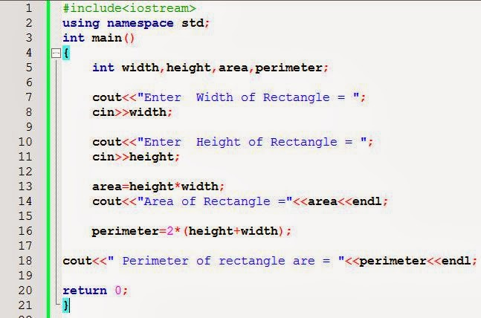

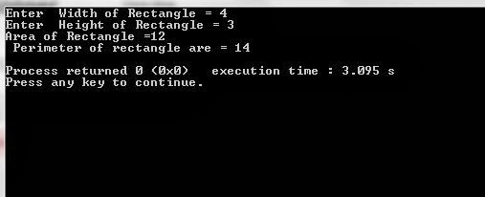

C. Event Driven Programming Paradigm

In computer programming, event-driven programming is a programming paradigm in which the flow of the program is determined by events such as user actions (mouse clicks, key presses), sensor outputs, or message passing from other programs or threads. Event-driven programming is the dominant paradigm used in graphical user interfaces and other applications (e.g., JavaScript web applications) that are centered on performing certain actions in response to user input. This is also true of programming for device drivers (Torte, 2022). This programming methodology is based on data and its movement. Program statements are defined by data rather than hard-coding a series of steps. A database program is the heart of a business information system and provides file creation, data entry, update, query and reporting functions. There are several programming languages that are developed mostly for database application. For example SQL. It is applied to streams of structured data, for filtering, transforming, aggregating (such as computing statistics), or calling other programs. So it has its own wide application.

Advantages of Event-Driven Programming

1. Flexibility

Programmers that use event-driven can be altered easily if the programmer wants something to be changed. This paradigm allows the programmer to produce a form of their requirements.Programmers who are event-driven can be put together without too many problems and also the code and design can be easily altered because if something isn't right.

2. Suitability for Graphical Interfaces

Event-driven allows the user to select different tools from the toolbar to directly create what they need such as buttons, radio buttons, etc.

This also allows people to put objects where they want them and can directly edit. Some people find it easier to directly click on the thing they want to edit.

3. Simplicity of Programming

Event-driven can make programming easier for some by being able to directly edit the object you want the code for.

Another thing that can make the programming easier is that when using an event driven language such as visual basic it usually has predictive coding so when the user is coding it will predict what you want to do from what you are typing.

4. Easy to Find Natural Dividing Lines

it is easy to find natural dividing lines for unit testing infrastructure.

5. Highly Compostable

It is highly compostable.

6. Simple and Understandable

It allows for a very simple and understandable model for both sides of the DevOps Bridge.

7. Purely Procedural and Purely Imperative

Both purely procedural and purely imperative approaches get brittle as they grow in length and complexity.

8. A good way to Model Systems

It is one good way to model systems that need to be both asynchronous and reactive.

9. Allows for more Interactive Programs

It allows for more interactive programs. Almost all modern GUI programs use event-driven programming.

10. Using Hardware Interrupts

It can be implemented using hardware interrupts, which will reduce the power used by the computer.

11. Allows sensors and other hardware

It allows sensors and other hardware to easily interact with software.

Disadvantages Event-Driven Programming

1. Complex

For simple programs, event-driven programming is often more complex and cumbersome than batch programming.

2. Less Logical and Obvious

The flow of the program is usually less logical and obvious

3. Difficult to find Error

Errors can be more difficult to spot than with simpler, procedural programs.

4. Slower

Programs with complex GUIs may be slower to load and run than simpler programs particularly if RAM is insufficient.

5. Confusing

Programs with too many forms can be very confusing and/or frustrating for the user

6. Tight Coupling

Possible tight coupling between the event schema and the consumers of the schema.

7. Blocking

Reasoning about blocking operations might be becoming more difficult.

Example of Event Driven Paradigm :

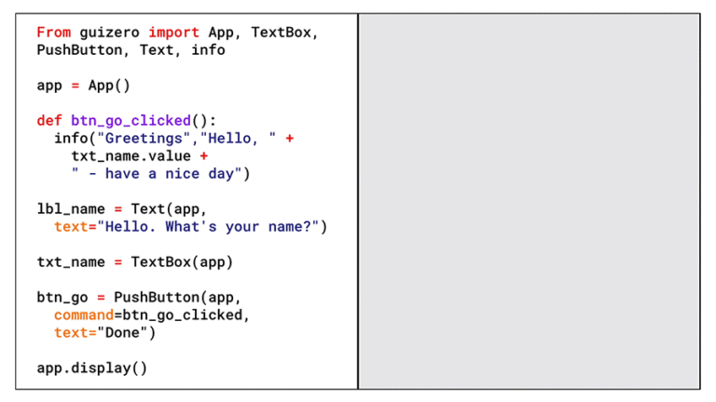

**1.3**

The programming paradigms I used in this project.

1. Object Oriented Programming (OOP) paradigm.

I have used object-oriented programming paradigm because I have created an object which has its own state which is only modified by built in procedures and in this case that is a Student class that I have created.

2. The Functional Programming paradigm

I've been using the functional programming paradigm because I've created a calculation that calculates the results of a test that students/examinee will take.

**The implementation & example will be used :**

-classes

Classes in object oriented programming serve as the blueprint for the entire structure of the code. Classes are data types that are defined by the developer. It can be viewed as one of the most crucial fundamentals of object oriented programming. An OOP class is a template that can be used to create objects, provide values to attributes, and implement methods or functions. Example of creating a java class for storing the main/important data:

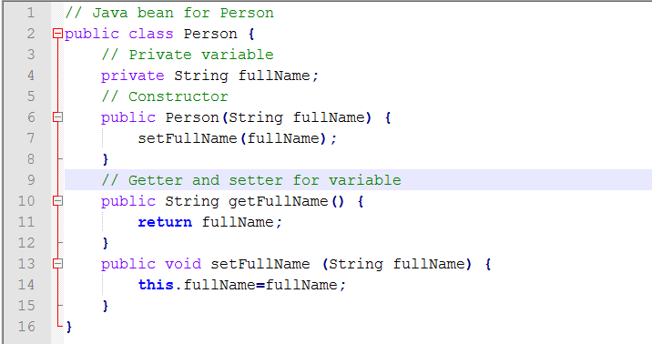

-Objects

In this type of programming, an object is an instance, or a variation, of a class with clearly-assigned data. If you were to set the class to ‘animals’, an example of an object that would serve as an instance would be ‘cat’. An object can be attributed to real-world items or abstract entities. Examples of creating an object of Student class:

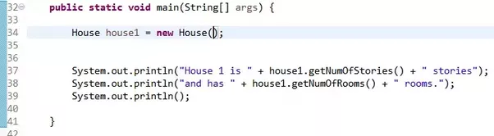

-Methods

Object oriented programming methods are procedures related to classes. They describe the behavior of an object. Put simply, a method is an action that an object can perform. A ‘person’ class could have methods like ‘eating’ or ‘singing’. An object oriented programming method is often compared to a function but they differ in that the latter is task-based. Example of a method with params and nested methods



**Task 2:**

2.1

Here is the 5 features that essential and useful in Eclipse.

1 Code Suggestion

Code suggestion is a feature that suggests possible completions for code as you type, based on the context of your code and the language you use. It can help you write code faster by reducing the amount of typing you have to do, and it can also help you avoid syntax errors by suggesting valid code snippets. For example, if you are typing a line of code and need to access a particular object or method, the code suggestion feature might offer suggestions for object or method names that are valid in the context of your code. This can be especially useful if you are working with a language or framework that has a lot of objects, methods, or functions, as it can help you quickly find and use the ones you need. Overall, code suggestion or autocompletion is a helpful feature that can save you time and effort while you are coding. You have to press the CTRL+Space in the same time to show the Template Proposals.

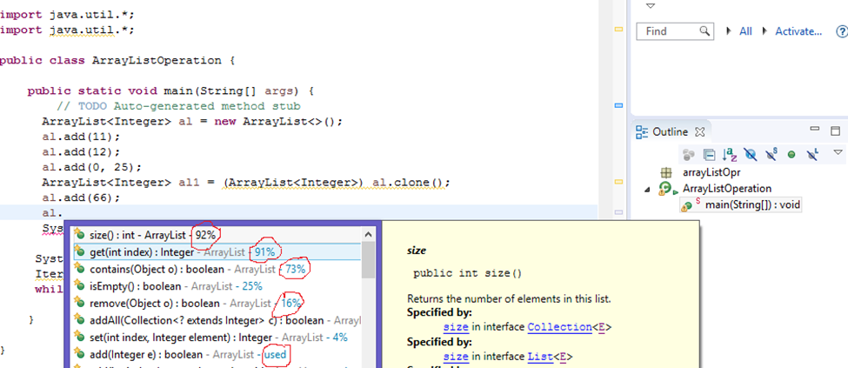

2. Error Highlight

Error highlight is a feature that highlights syntax errors and other issues in your code, making it easier to spot and fix problems. This can be a handy feature, especially when working on a large or complex codebase. It can help you quickly identify and resolve issues that might otherwise be difficult to find. Some code editors and IDEs will highlight errors in real-time as you type, while others may require you to run a separate "linting" or "syntax checking" tool to identify issues. Either way, error highlighting is an important feature that can help you write cleaner, more reliable code. In addition to highlighting syntax errors, many code editors and IDEs also offer additional error-checking and debugging tools, such as the ability to trace the flow of control through your code or inspect the values of variables at different points in your program. These tools can be beneficial when trying to understand why your code is not working as expected.

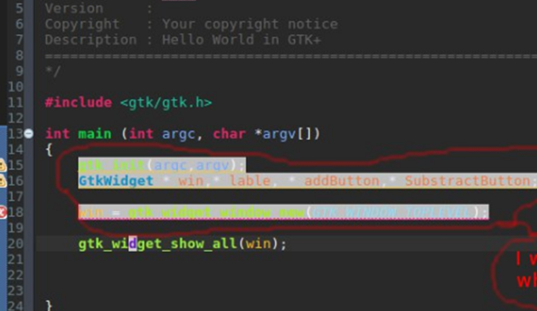

3. Debugging Debugging is the process of identifying and fixing errors in your code, and debugging tools are an essential part of this process. Debugging tools allow you to step through your code line by line, execute individual lines of code, and inspect the values of variables at different points in your program. This can be extremely helpful when trying to understand why your code is not behaving as expected, as it allows you to see what is happening inside your code at a deficient level. Many code editors and IDEs include built-in debugging tools or standalone tools designed to work with a specific programming language or environment. Some standard features of debugging tools can set breakpoints, step through code, inspect variables, and see the flow of control through your code. Overall, debugging tools are an essential part of the software development process, and they can save you a lot of time and frustration by helping you identify and fix errors in your code

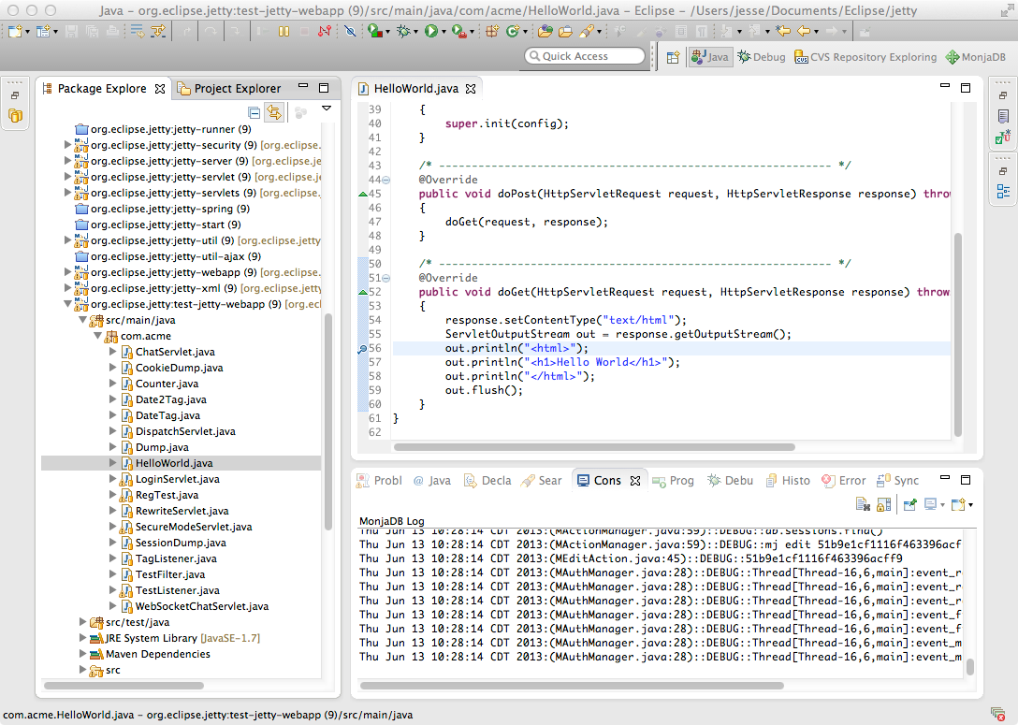

1. Syntax Color Highlights Syntax highlighting is a feature that changes the color of different parts of your code based on the language you are using. This can make your code easier to read and understand, as it helps visually distinguish between different code elements, such as keywords, variables, and functions. For example, in a language like Python, keywords like "if" and "for" might be highlighted in blue, while variables might be highlighted in green, and functions in purple. This can help you quickly identify different parts of your code and understand how they are related to each other. Syntax highlighting is often customizable, so you can choose the colors and styles that work best for you. Many code editors and IDEs include syntax highlighting by default, and you can usually customize the colors and styles to suit your preferences. Overall, syntax highlighting is a helpful feature that can make your code easier to read and understand, and it can be especially useful when you are working with large or complex codebases

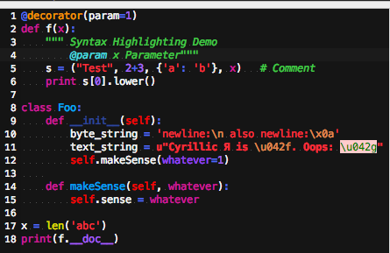

5. Refactoring

Refactoring in Eclipse includes a refactoring tool that allows you to safely and easily make changes to your codebase, such as renaming variables or moving code between files.

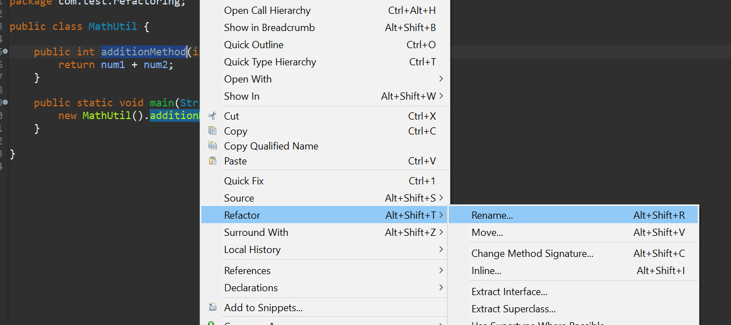

2.2

Solution:

As I mentioned earlier regarding the features that are in the IDE, it is very clear that using it will be very helpful when writing code.

And also, IDE makes coding more efficient by providing support for syntax highlighting, code completion, project management, and much more

So if we don't use an IDE it will take a lot of time and our work will be very inefficient, considering we have to do everything manually, and if we miss something, we are never reminded about it.

|  |  |
| --- | --- |
| IDE | Non-IDE |
| ECLIPSE | Notepad, sublime,wordtext |
|  | CMD,JDK |
|  | Use CMD |
|  |  |

If we are using an IDE will be so simple and will manage us to create the code easier.

IDE :

Eclipse :

Eclipse is an integrated development environment (IDE) for Java and other programming languages like C, C++, PHP, and Ruby etc. Development environment provided by Eclipse includes the Eclipse Java development tools (JDT) for Java, Eclipse CDT for C/C++, and Eclipse PDT for PHP, among others.

Opening the New Java Project wizard

The New Java Project wizard can be used to create a new java project. There are many ways to open this wizard −

* By clicking on the File menu and choosing New →Java Project.
* By right clicking anywhere in the Project Explorer and selecting New → Java Project.
* By clicking on the New button ( ) in the Tool bar and selecting Java Project

Using the New Java Project wizard

The New Java Project Wizard has two pages. On the first page −

* Enter the Project Name
* Select the Java Runtime Environment (JRE) or leave it at the default
* 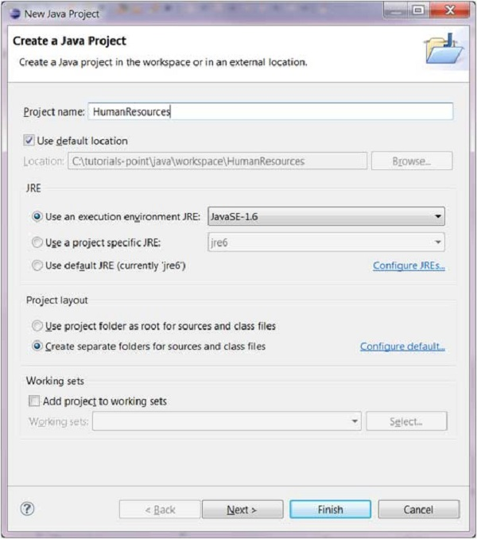Select the Project Layout which determines whether there would be a separate folder for the source codes and class files. The recommended option is to create separate folders for sources and class files.

You can click on the Finish button to create the project or click on the Next button to change the java build settings.

On the second page you can change the Java Build Settings like setting the Project dependency (if there are multiple projects) and adding additional jar files to the build path

Viewing the Newly Created Project

The package explorer shows the newly created Java project. The icon that represents a Project is decorated with a J to show that it is a Java Project. The folder icon is decorated to show that it is a java source folder.

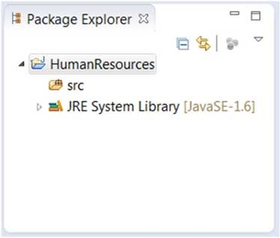

Create java package :

Opening the New Java Package wizard

You can use the New Java Package wizard to create a Java package. The Java Package wizard can be opened in different ways −

• By clicking on the File menu and selecting New → Package.

• By right click in the package explorer and selecting New → Package.

• By clicking on the package icon which is in the tool bar( ).

If you are creating a sub package, before opening the Java Package wizard select the parent package so that name field can have a default value in it.

Using the New Java Package Wizard

Once the Java Package wizard comes up −

• Enter/confirm the source folder name.

• Enter the package name.

• Click on the Finish button.

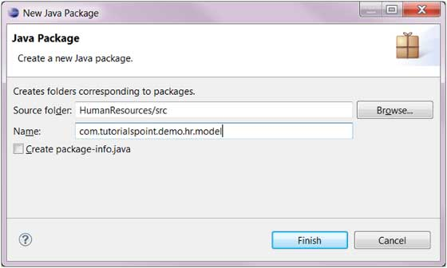

Viewing the Newly Created Package

The package explorer will show the newly created package under the source folder.

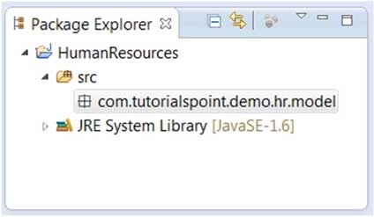

-create java class

Opening the New Java Class Wizard

You can use the New Java Class wizard to create a Java class. The Java Class wizard can be invoked in different ways −

* By clicking on the File menu and selecting New → Class.
* By right clicking in the package explorer and selecting New → Class.
* By clicking on the class drop down button ( ) and selecting class ( ).

Before invoking the New Java Class wizard, if possible, select the package in which the class will be created so that the wizard will automatically populate the package for you –

• Make sure that the source and package directory are correct .

• Enter the name of the class.

• Select the appropriate class modifier.

• Enter a superclass name or click the Browse button to search for an existing class.

• Click the Add button to select the interfaces implemented by this class. • Check and change checkboxes for method notes and comments.

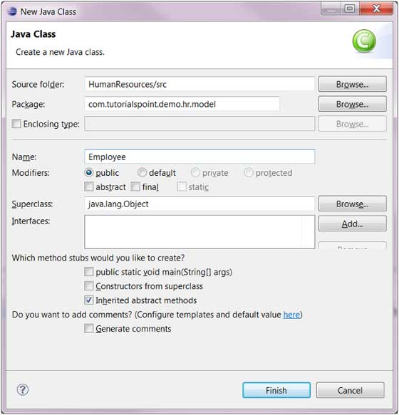

• Click the Finish button. Viewing the newly created Java class The newly created class should be closed in Explorer view and appear in an instance of the Java editor that you can use to modify the new class. It should appear in the editor area

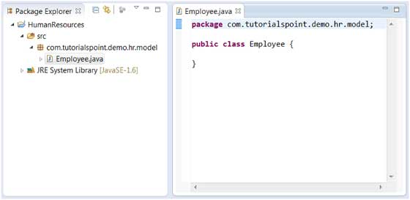

Non IDE :

Download JDK

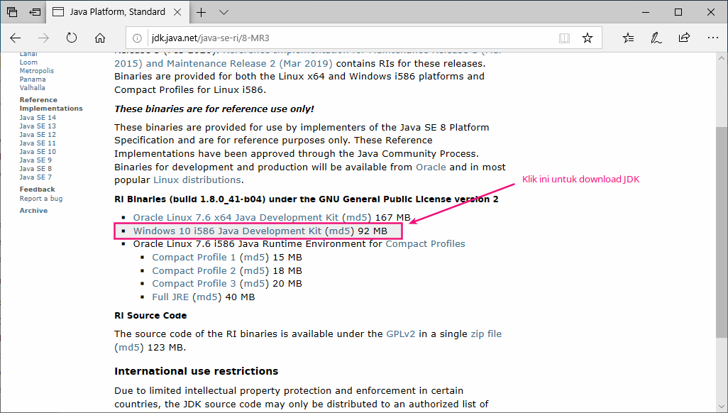

After that, we will get a ZIP file containing the JDK. Please extract this file

into **C:\Program Files\**.

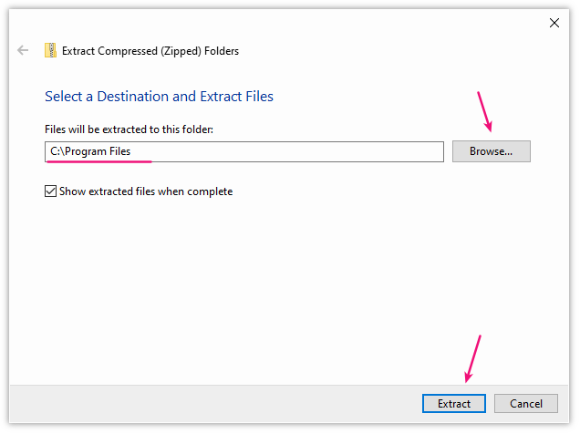

So now we will have a new folder, namely **java-se-8u41-ri**

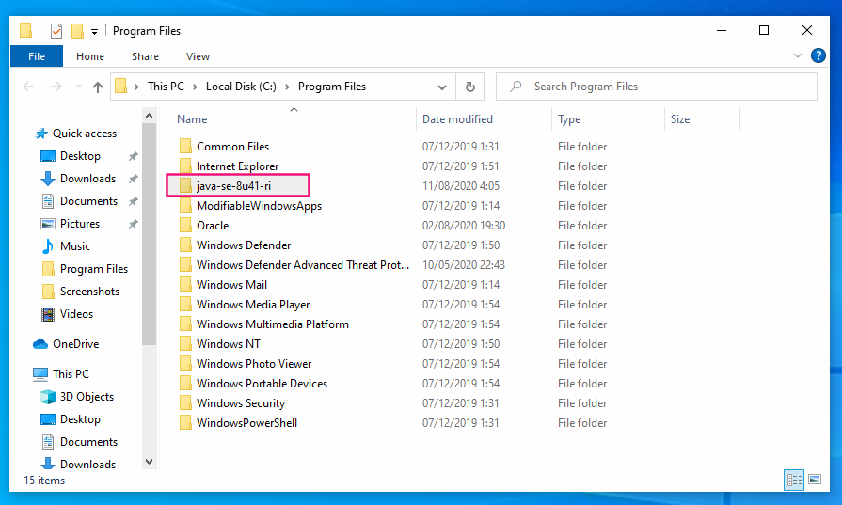

At this point, we actually have the JDK installed. However, it can't be used yet.

If you don't believe...

Try opening CMD and typing java or javac.

Then the result:

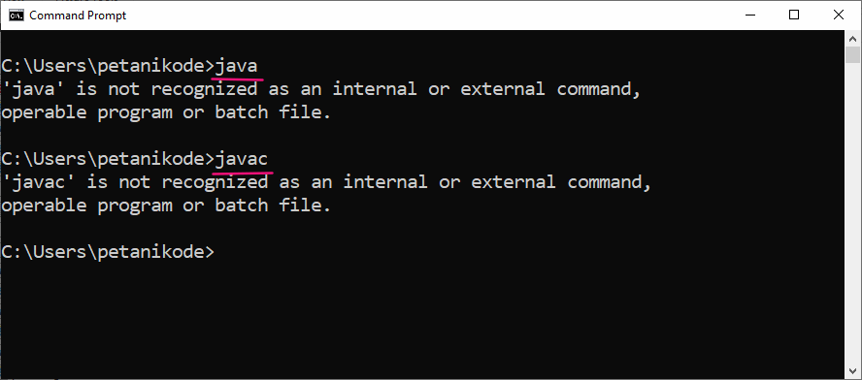

Command java and javaccannot be recognized in CMD yet.

The command javacfunctions to compile Java programs and javafunctions to run Java programs.

In order for these two commands to be recognized, we must register them in an *Environment Variable* .

Let's do it:

Please click Start Menu , then type env . Then it will appear like this:

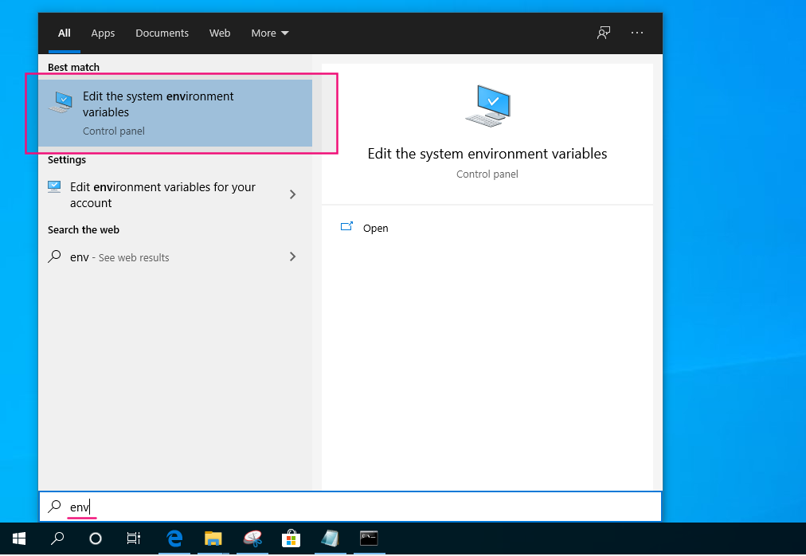

Please open the Edit the system environment variables program , so it will appear like this :

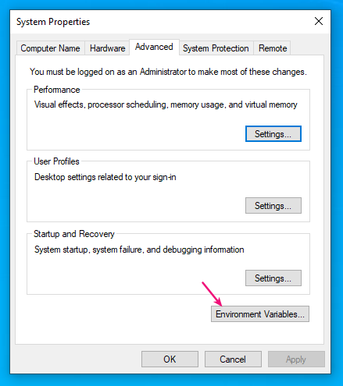

**Click**Environment Variables**, then in the window that appears click**New

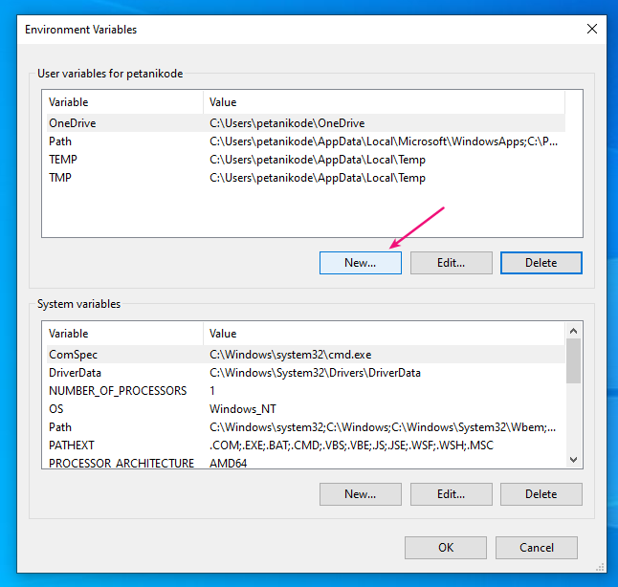

So it appears like this :

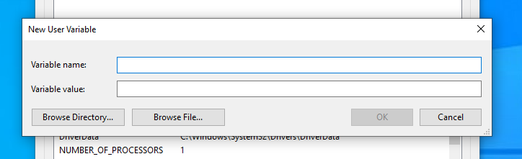

. Here we create a new variable called JAVA_HOME and the value is the JDK path address. The purpose of creating the variable is JAVA_HOME, so later the installed JDK is determined by Netbeans. Please open Windows Explorer and then navigate to the folder where we extracted the JDK earlier. Right-click on the address bar and then select Copy address as text

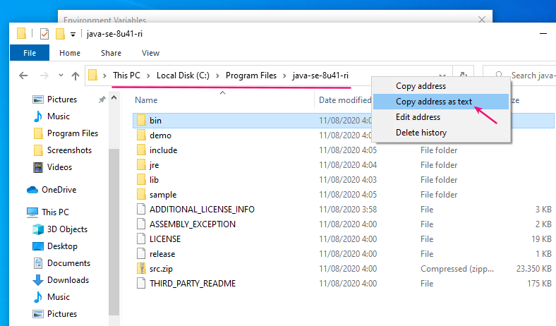

After that, go back to the variable creation window and *paste* the address into the value of the variable JAVA_HOME

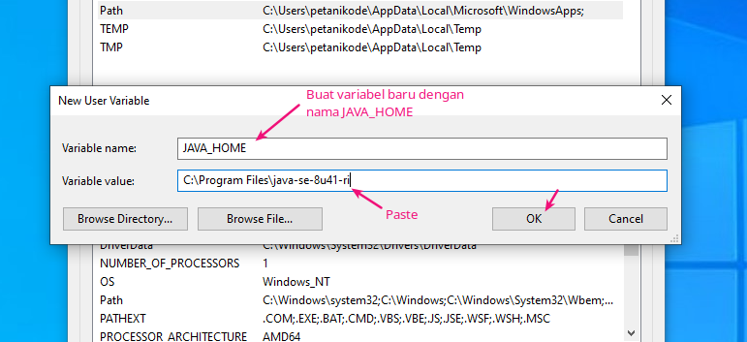

After that, we will have a new variable named JAVA_HOME. Next, please edit the variable Path.

Click the variable Paththen click the Edit button

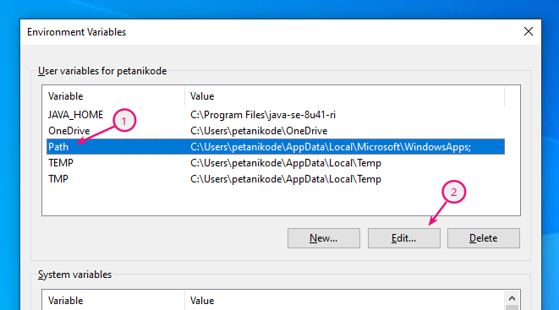

In the window that appears, click the **New** button and fill it with**%JAVA_HOME%\bin**

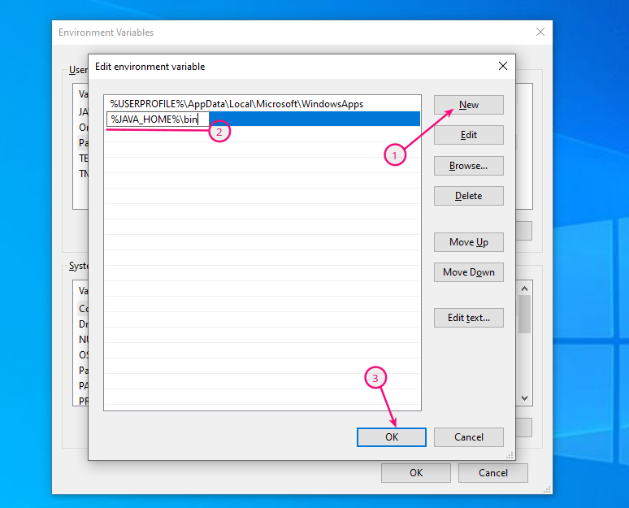

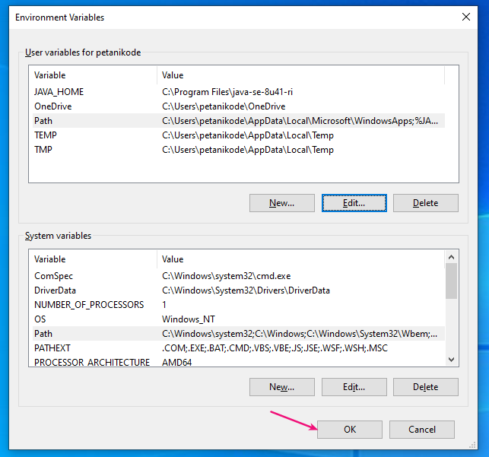After that, click OK to save all the variables that have been created

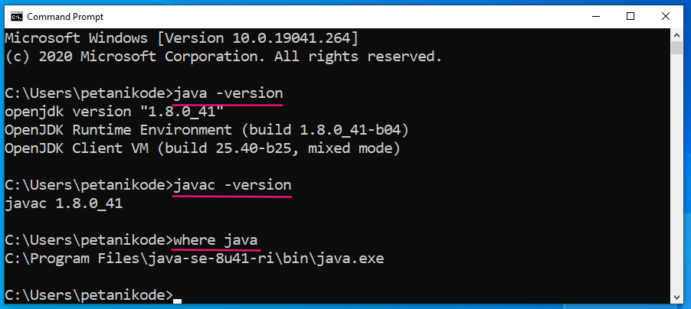Then the result:

**Experiment Making Hello World Program**

To make sure the JDK is installed correctly, let's try it by creating a **HelloWorld** program .

Please open Notepad, then type the following program code:

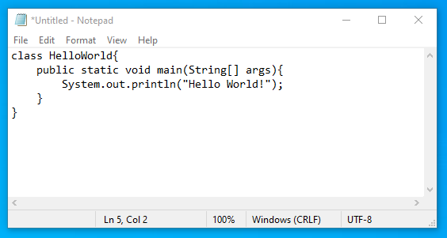

After that, save it in the **Documents** folder with the name **HelloWorld.java**.

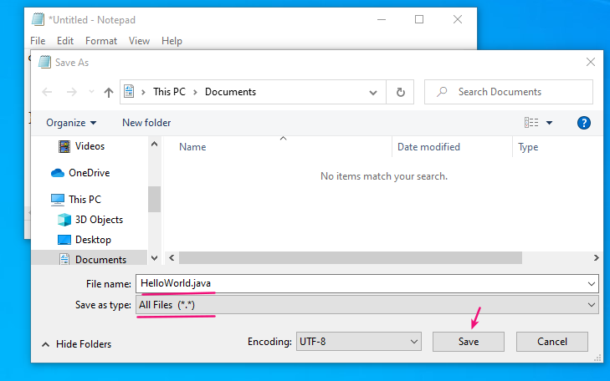

Next, we will *compile* the program.

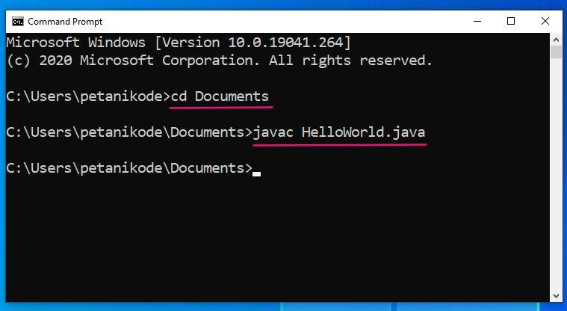

Now, we have a new file in the **Documents** folder named **HelloWorld.class**. This file is a compiled result from a Java program **HelloWorld.java**

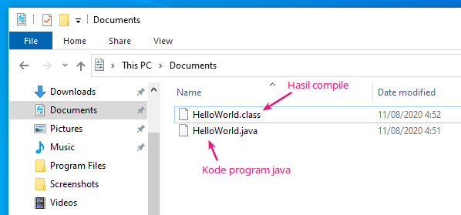

Next, return to CMD and type the following command to execute the program

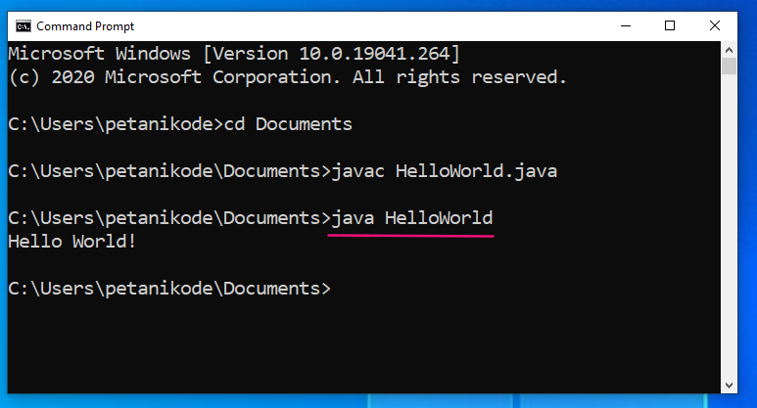Then the result:

**TASK 3**

* 1. Document the architecture of the system along with modul and its component description.

To begin with, we need to comprehend the issue that the program is supposed to answer. Additionally, any guidelines that must be followed. In this instance, North Sussex Judo has been asked to use a program that must estimate the monthly cost of training fees for its athletes. This program was created by entering data, which is made up of figures in each training session, including the session fee, and will be used as information to calculate the overall monthly cost.

Based on the data, we plan to suggest the following system architecture for the project:

The program will ask the user for the necessary data, such as session data from each training session, and will utilize that information to determine the overall cost for each month before showing the user the final cost.

Modules: The software will be broken up into several modules, such as classes, methods, variables, etc.

classes: This program has a class for athletes, which holds information about each athlete, including name, goals, current weight, competition weight category, and number of competitions.

Method:

*Accepted user inputs: Make it simple to be in charge of accepting user input From the user, such as number of training sessions and the cost/sessions.

*The overall cost for the month will be determined by thecostcall based on user input

and

*the output display will be computing cost to the user, along with athlete’name and an itemized list off all cost for the month.

Variable: This software uses the variable to store data, including the quantity and cost of sessions.

Object: A produced object by the athlete class software to denote a certain athlete.

For instance, each of the items in the athlete class makes the class unique.

The NSJ training cost calculator will be a program that allows users to input data about the athletes and calculates the total cost of training fees for the each months. The program will consist an athlete class. Three main method will be accepting the input. Calculating the total cost and display the results. And variable to store data, it also create the object to represent the specific athletes and have a unique instance for each object.

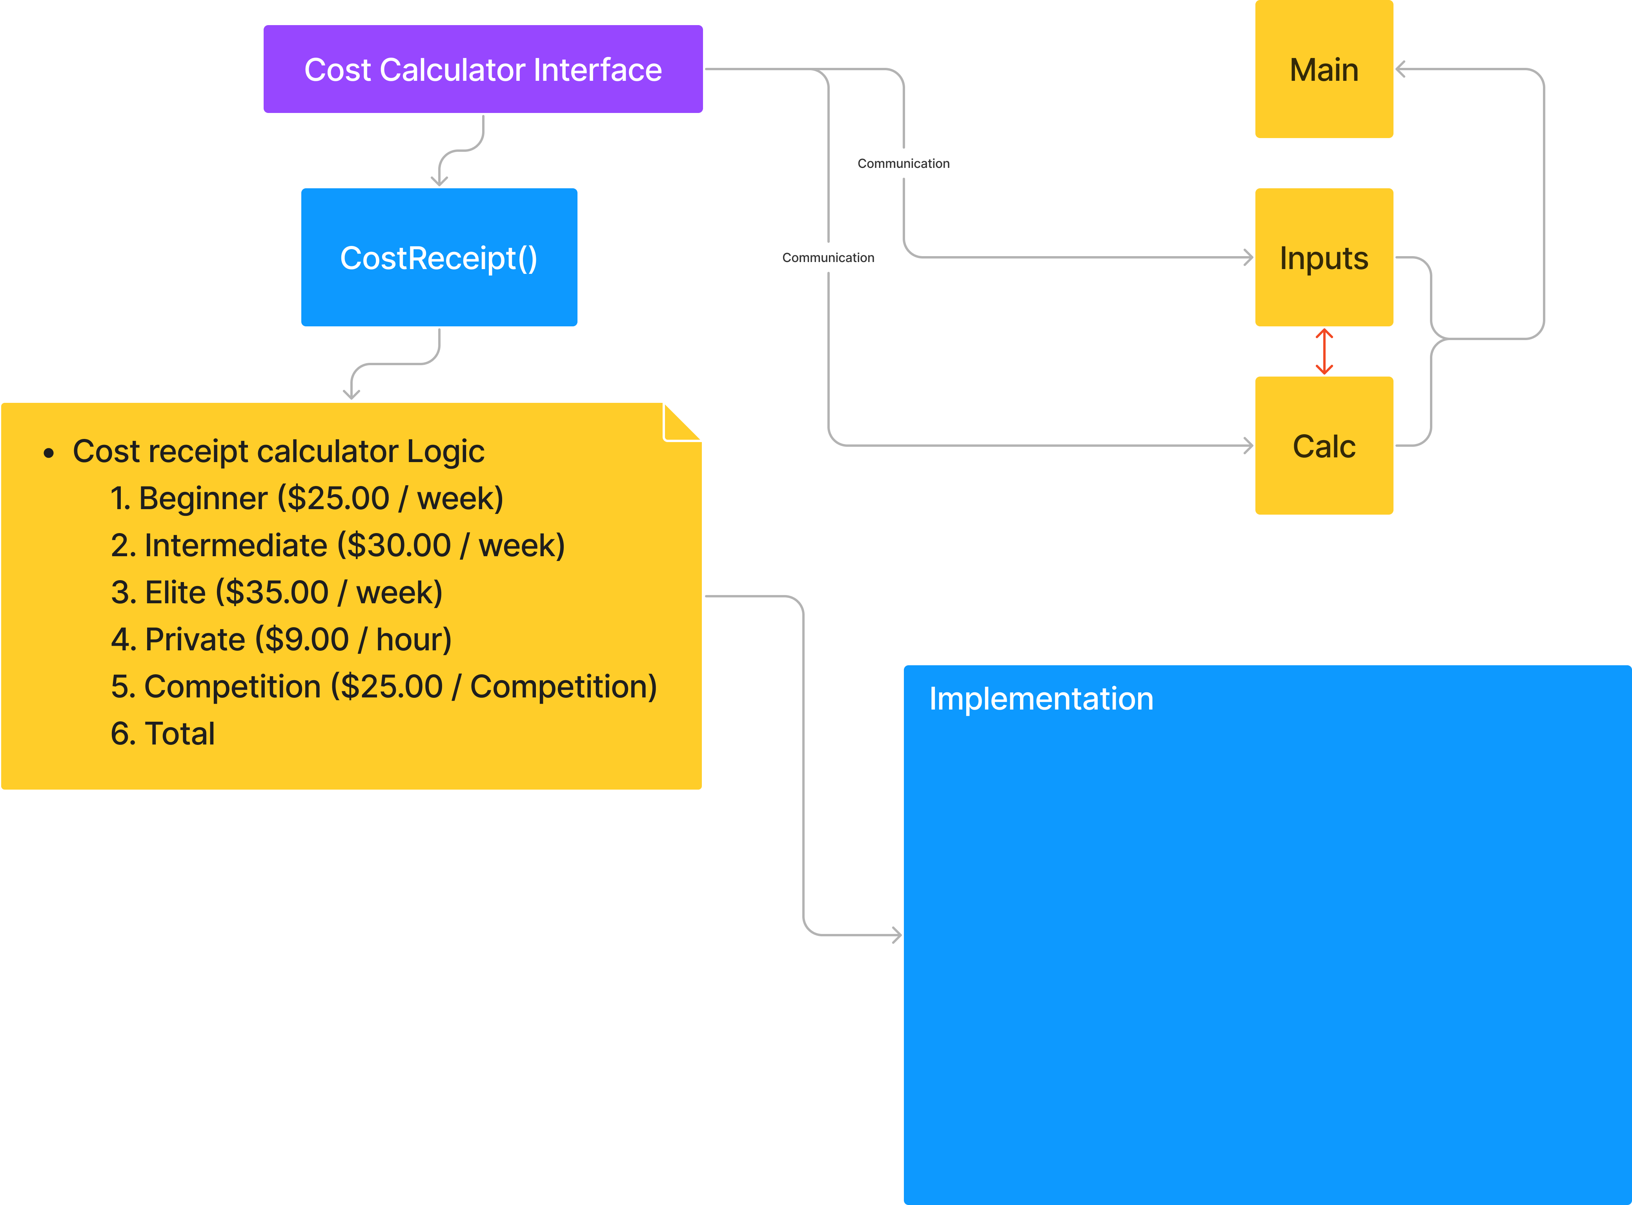

$$a×b= x$$

$$x+c (if there are)=y$$

$$x+z (if there are)=i$$

$$x+c+z\left(if there are\right)=p$$

$$a=cost level$$

*b $=number of weeks / 4$*

$$c=private tuition$$

$$z=competition costs$$

Private tuition ( *c* )

$$c=9.00 × number of hours$$

Total (*x* & *y* & *i* & *p* )

Total is *y* if there are additional private tuition.

Total is *x* if there are no additional private tuition & competition.

Total is *i* if there are additional competition & no private tuition.

Total is *p* if there are additional competition & private tuition.



. 3.2: Algorithm

* An algorithm is a collection of instructions that a computer must follow in order to carry out calculations or other problem-solving tasks.
* A formal definition of an algorithm states that it is a finite set of instructions that are followed in a particular order to complete a specified goal.
* It's not the whole program or code; rather, it's a flowchart or other informal depiction

of the problem's straightforward logic.

Each algorithm has the following characteristics:

* Input: Each algorithm needs some input data. A value other than 0 may be provided as input to an algorithm.
* Output: An algorithm will produce one or more results at its conclusion.

• Unambiguity: A perfect algorithm must be unambiguous, which implies that its directives must be plain and simple.

• Finiteness: A finite algorithm is required. In this context, "finiteness" refers to the requirement that an algorithm have a finite number of instructions, or instructions that can be counted.

• Effectiveness: An algorithm must be effective because every instruction has an impact on the whole procedure.

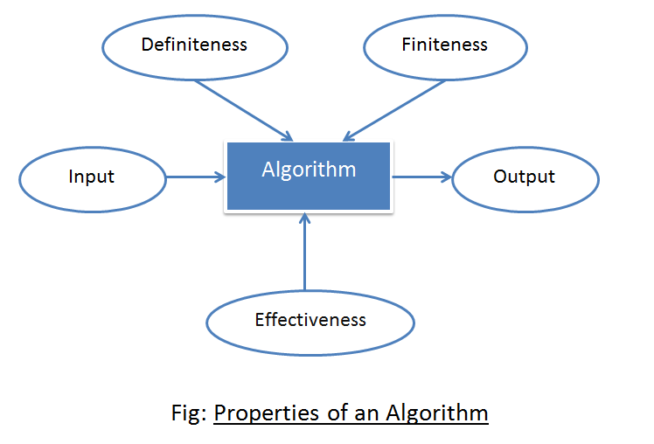

* Benefit algorithm :
  1. Better problem solving
  2. Improves efficiency
  3. Provides clarity
* Type of algorithm :

1. Brute Force Algorithm: This is the most fundamental and straightforward type of algorithm. A Brute Force Algorithm is the simplest solution to a problem, or the first solution that comes to mind when we see the problem.

2. Algorithm Recursive:

Recursion is used in this type of algorithm. In recursion, a problem is solved by breaking it down into subproblems of the same type and repeatedly calling own self until the problem is solved with the help of a base condition.

3. Randomized Algorithm: A random number is used in the randomized algorithm. It aids in determining the expected outcome.

4. Algorithm for Sorting:

Sorting algorithms are used to arrange data in ascending or descending order. It is also used to organize data in an efficient and useful way.

5. Searching Algorithm: The searching algorithm is the algorithm used to find a specific key in a set of sorted or unsorted data.

6. Hashing Algorithm: Hashing algorithms work similarly to Searching algorithms, but they include an index with a key ID, i.e. a key-value pair.

7. Divide and Conquer Algorithm: The algorithm divides the problem into subproblems, solves one subproblem and the final solution to get the final solution. It consists of three steps:

- Splitting

- Solving

- Combining

8. Greed Algorithm: In this algorithm, the solution of next part is made based on the immediate profit of the next part.

9 Dynamic programming algorithm: uses the concept of using already found solutions to avoid recalculating part of the problem. It breaks down a problem into smaller sub-problems that fit together and solves them.

10. Backtracking algorithm: builds a solution by searching all possible solutions. We will proceed with the solution according to the norms.

Conclusion: An algorithm is a problem-solving procedure language or formula. The issue is based on a survey.

A series of specified actions. A computer program can be viewed as a complex algorithm. In the fields of mathematics and computer science. An algorithm is typically defined as a short procedure that solves a recurring problem. Algorithms are widely used in all areas of information technology. As an example, a search engine algorithm accepts keyword and operator strings as input. It will also search its associated databases for relevant web pages and return the results.

Advantages of algorithm :

* easy to understand.
* Algorithm is a step wise representation solution to given a problem
* In algorithm the problem is broken down into smaller pieces of steps hence, it is easier for the programmer to convert it into an actual program

Disadvantages of algorithm :

* Writing an algoritm takes a long time.
* Understanding complex logic through algorithms can be difficult
* Branching and looping statements are difficult to show algorithm.

Algorithm for the project :

START

(MENU)

INPUT ATHLETE NAME

Display again

DISPLAY TRAINING PLAN

Beginner ($9.00) / WEEK

Intermediate($30.00)/WEEK

Elite ($35.00)/WEEK

NON VALID

enter

VALID

PLEASE INPUT YOUR WEIGHT

CHOSE WEIGHT COMPETITION CATEGORY

Heavy-weight (over 100 kg)

Light-weight (100 kg)

Middle weight (90 kg)

Light-middle weight(81 kg)

Light-weight(73 kg)

Flyweight(66 kg)

YES

valid

DISPLAY

DISPLAY AGAIN

Non valid

ADDITIONAL IF ELSE

INPUT

NON VALID

VALID

PLEASE INPUT HOUR YOU WANT

ACCUMULATE & CALCULATE TOTAL COSTING

AFTER COMPARE WEIGHT + WEIGHT COMPETITION CATEGORY

CALCULATE/MONTH

CALCULATE/MONTH

**3.3**

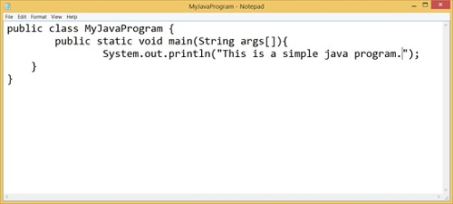

Step 1: Write a Java program:

By writing a Java program on any editor or IDE, we mean creating a Java program. This includes modifying the program on the editor after it has been written once. The creation of a Java program is not limited to simply writing the program on an editor and then leaving it. In general, creating a Java program entails writing a program in an editor or IDE, making all necessary corrections, and then saving the program to a secondary storage device such as a hard drive.

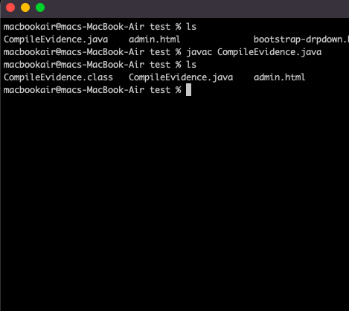

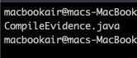

Step 2: Create a Java Program

Following the creation of the program, the compilation of the Java program is our next step. The compiler generally compiles the Java program that we created in step 1 with a.java extension. Assume we have a program called WelcomeJavaPrograms.java, and we want to compile it using a command like javac. It is known as the Java compiler. We compile a Java program with the.java extension after opening the command prompt or shell console.

javac WelcomeJavaPrograms.java.

If no errors occur in our program after running the javac command, we will receive a.class file containing the bytecode. This indicates that the compiler successfully converted the Java source code to bytecode. The JVM typically uses bytecode to run a specific application. JVM is a virtual machine that sits between our bytecode and the underlying operating system. When creating a Java program, you should provide the executable file that only the JVM understands. To file, add a java extension. It denotes that the file in question is Java source code.

**Bytecode**

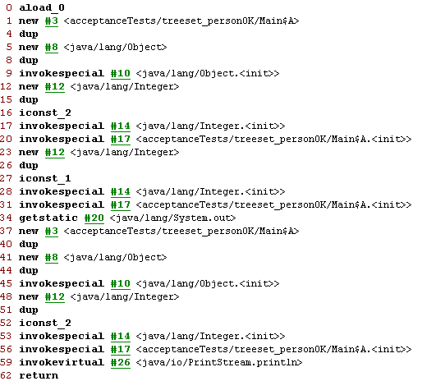

**JVM loads the program into memory:**

Step 3 :

JVM needs memory to load the.class file before it can execute it. Loading refers to the process of storing a program in memory so that it can be executed. The JVM includes a class loader, whose primary function is to load the.class file into primary memory for execution. The class loader loads all of the.class files required by our program for execution into memory just before execution.

**Loader into memory & Execution Engine**

Step 4: JVM Verification of Bytecode**:**

JVM includes a bytecode verifier to ensure program security. After the classes are loaded into memory, the bytecode verifier enters the picture and verifies the bytecode of the loaded class to ensure security. It determines whether bytecodes are valid. As a result, it protects our computer from malicious viruses and worms.

Step 5: Run the Java program:

JVM executes the actions we've written in our Java program by interpreting bytecode. Old JVMs were slow and only executed and interpreted one bytecode at a time. Modern JVMs employ a JIT compilation unit, also known as just-in-time compilation. These compilers run multiple instructions in parallel. Because JVM uses them to find hot spots in bytecode, they are also known as Java HotSpot compilers. By hot spots, we mean that the JVM analyzes bytecode by looking for places in the program that are frequently executed. These are quite common.

The Java HotSpot compiler converts executable bytecodes to faster machine language code. The significance of this is that whenever JVM encounters such parts in bytecode again, it processes machine language code, which is much faster than executing one byte code at a time.

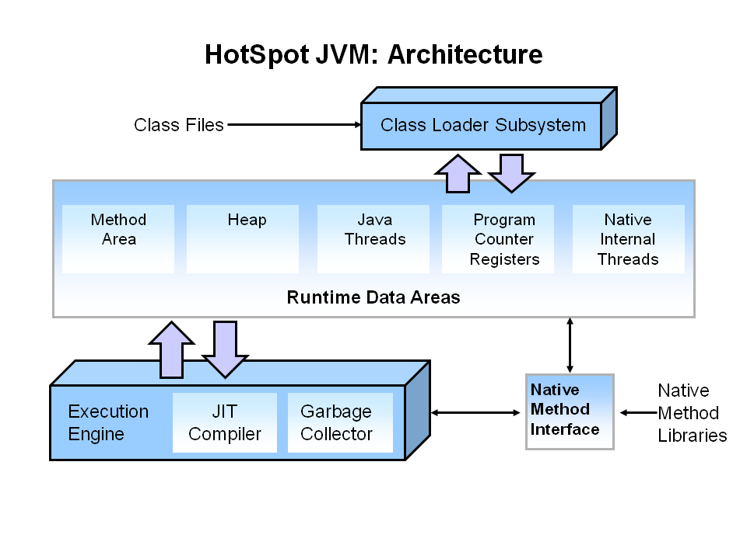

CREATE THE PROJECT of

JVM

+

COMPILE : JAVA to class file

initialization

lingking

loading

MEMORY

EXECUTION ENGINE

**TASK 4**

4.1

Develop a fully object-oriented solution by providing source code of implementation for the algorithm written in Mini project :

-Algorithm :

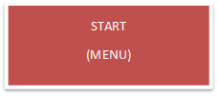

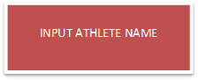

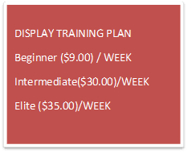DISPLAY

NON VALID

AGAIN

NO

VALID

YES

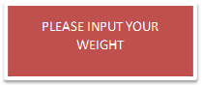

(VALID) YES

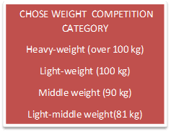

YES YES

VALID

NON VALID

NO (DISPLAY AGAIN)

YOU CAN JOIN THE COMPETITION

(ADDITIONAL PRIVATE COACHING)

YES NO

IF ELSE

YOU CANNOT

JOIN THE COMPETITION(FOR BEGINNER)

VALID NON

YES VALID

(DISPLAY AGAIN)

INPUT

HOUR

YOU WANT

ACCUMULATE & CALCULATE TOTAL COSTING

CALCULATE/MONTH

END

AFTER COMPARE WEIGHT + WEIGHT COMPETITION CATEGORY

CALCULATE/MONTH

* Tool IDE used for Implementation : Eclipse IDE



. Java-primarily based totally improvement platform acknowledged for its plugins that permit builders to broaden and check code written in different programming languages. Eclipse is launched below the phrases of the Eclipse Public License

* Java Classes
* 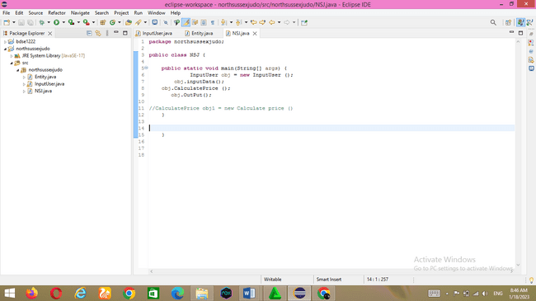NSJ.Java

This NSJ Class is in which to run the class that become created earlier. Entity class and InputUser Class will run on this class

* Entity class

All parameters are defined in this class. All parameters are private to use the oops encapsulation function. Getters and setters are created for each parameter so that child classes can use those parametersity Class

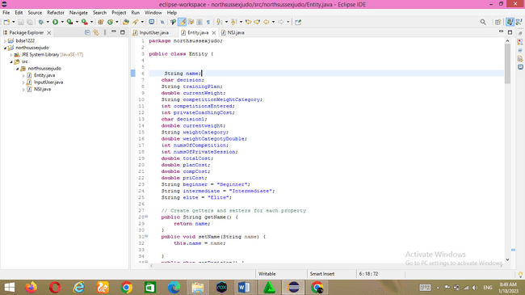

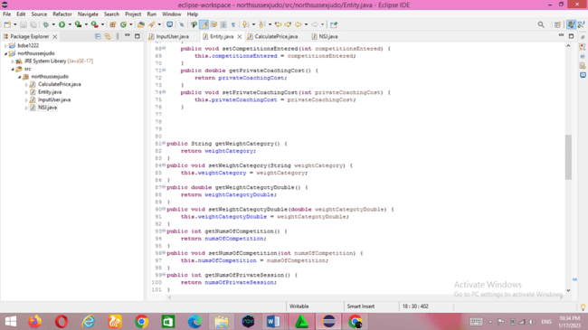

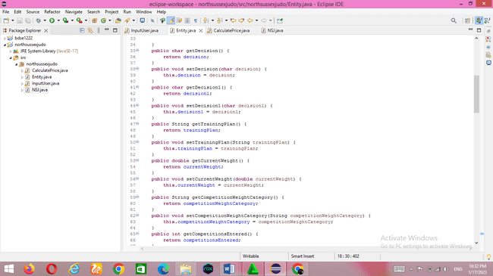

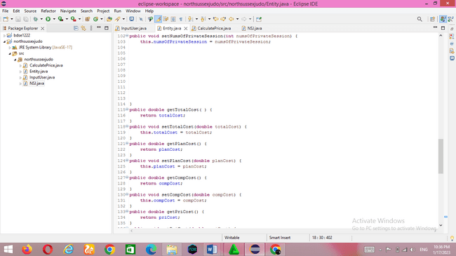

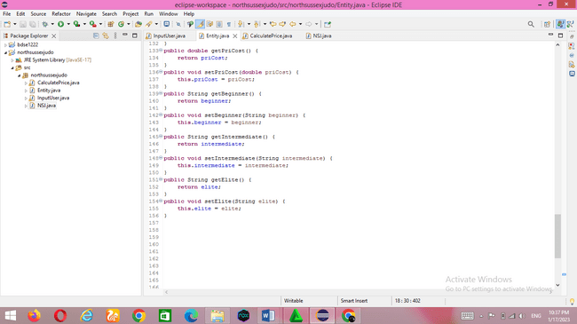

* InputUser class

The InputUser class extends the Entity class. This class uses the concept of inheritance so that it can access the members of the object class. This class takes user input and also validates whether the input is valid or not. If the input is incorrect, the application prompts the user for valid input until he or she enters the correct input

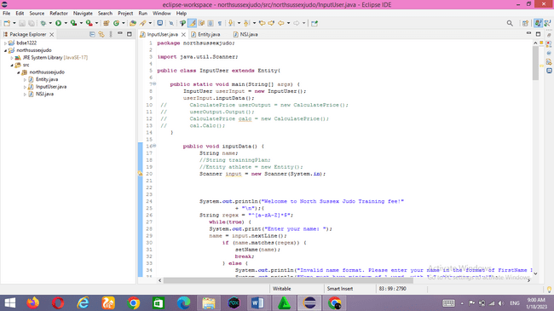

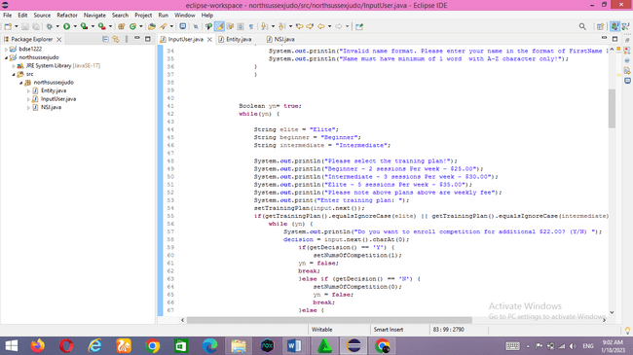

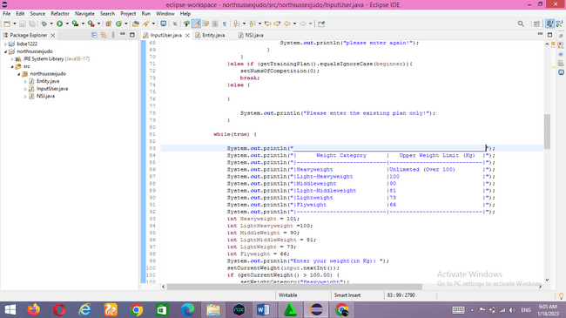

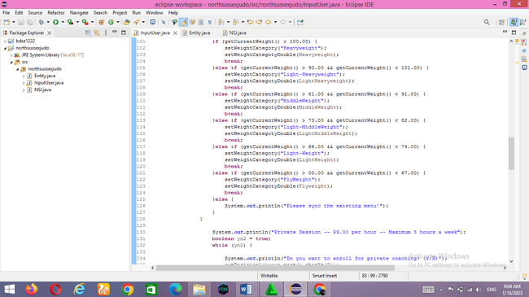

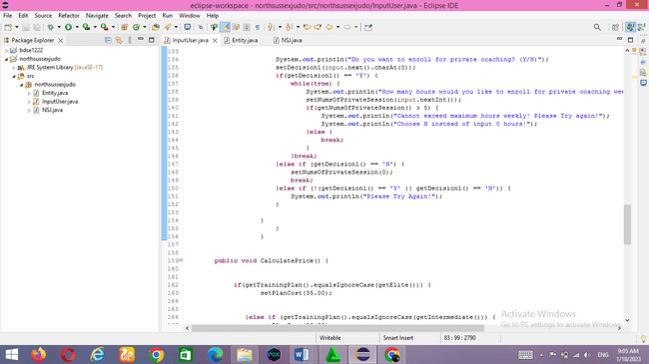

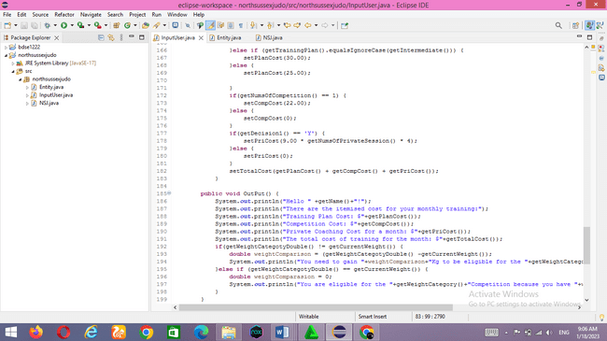

* Project output screen captures

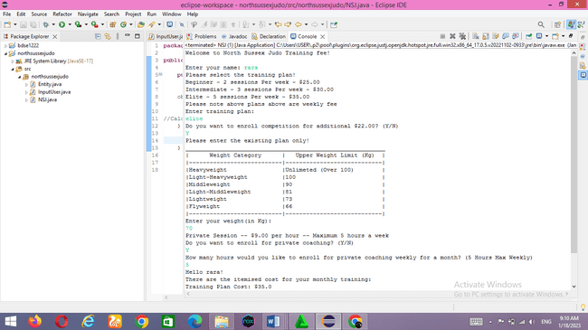-Athlete 1 (rara) with including correct output.

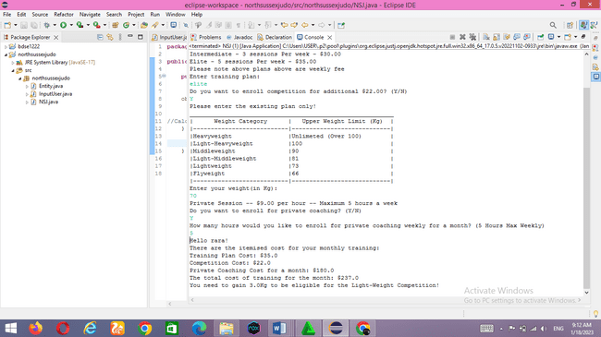

-Athlete 2, with including incorrect output and execution handling.

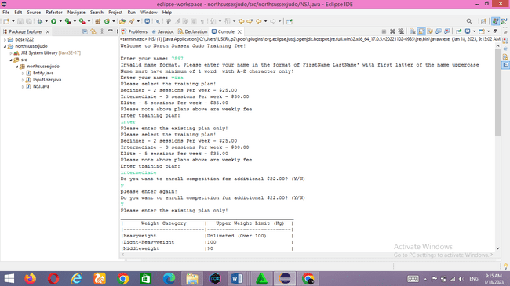

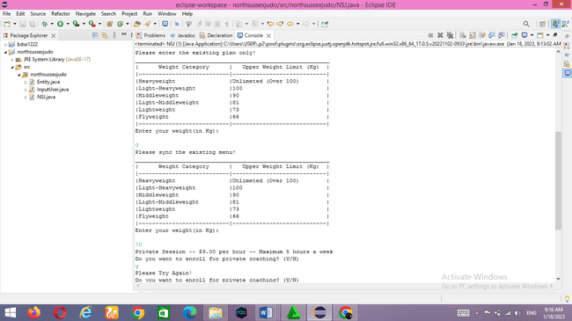

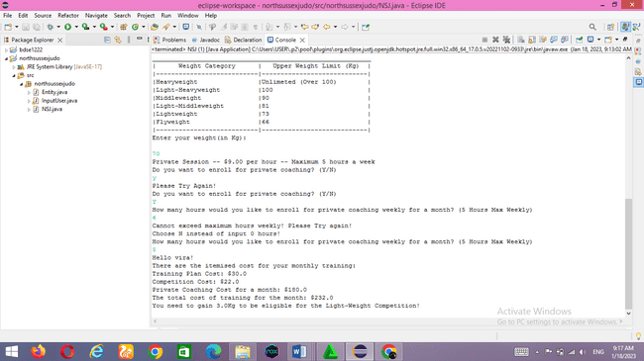

4.2 Provide a brief note on how the algorithm is translated to equivalent code.

Programming Languange : POP & OOPS

Programming Language : POP & OOPS

POP : A procedural language follows a sequence of statements or commands to achieve a desired result. Each set of steps is called a procedure, and a program written in one of these languages ​​contains one or more procedures.

OOPS : This type of language treats a program as a collection of objects consisting of data and program elements known as attributes and methods. Objects can be reused within an application or in other applications. This makes it a popular type of language for complex applications, as the code is easier to reuse and scale. For implementation we use Java.

programming paradigms are a way of classifying programming languages ​​based on their characteristics. Languages ​​can be divided into several paradigms. Some paradigms mainly deal with the influence of the language implementation model, such as B. the possibility of side effects, or whether the sequence of actions is determined by the implementation model.

Other paradigms mainly deal with the way code is organized, for example: B. Grouping code into units together with the state modified by the code. Others deal mainly with syntax and grammar. We will use the imperative language as a procedural paradigm and an object-oriented paradigm.

* Procedural programming is a programming paradigm based on the concept of procedure calls from imperative programming. Procedures (a type of routine or subroutine) simply contain a series of computer steps that must be performed. Any procedure can be called at any time during program execution, including by another procedure or by itself. Procedural programming languages ​​are also imperative languages ​​because they are directly related to the state of the execution environment. This can be anything from variables (which can correspond to processor registers) to the location of a "turtle" in the Logo programming language.
* COMPARISON WITH OTHER PARADIGMS

Often, the terms "procedural programming" and "imperative programming" are used synonymously. However, procedural programming relies heavily on blocks and scope, whereas imperative programming as a whole may or may not have such features. As such, procedural languages generally use reserved words that act on blocks, such as if, while, and for, to implement control flow, whereas non-structured imperative languages use goto statements and branch tables for the same purpose.

* Object-oriented programming The focus of procedural programming is to break down a programming task into a collection of variables, data structures, and subroutines, whereas in object-oriented programming it is to break down a programming task into objects that expose behavior (methods) and data (members or attributes) using interfaces. The most important distinction is that while procedural programming uses procedures to operate on data structures, object-oriented programming bundles the two together, so an "object", which is an instance of a class, operates on its "own" data structure.

Nomenclature varies between the two, although they have similar semantics:

|  |  |
| --- | --- |
| **Procedural** | **Object-oriented** |
| Procedure | [Method](https://en.wikipedia.org/wiki/Method_(computer_science)) |
| [Record](https://en.wikipedia.org/wiki/Record_(computer_science)) | Object |
| Module | Class |
| Procedure call | Message |

Languange Key Components :

⎫ java.lang package is automatically imported in every Java class. we can import all classes and sub-packages from a package by using the wildcard * e.g. import northsussexjudo* will import all classes on package northsussexjudo as well as classes on any subpackage. package must be the first statement, even before import statement in Java source file

⎫ Programmers should use hierarchical structure to define packages and sub-packages, as used in JDK itself e.g. java.util, then java.util.concurrent, then java.util.concurrent.atomic or java.util.concurrent.lock etc. Just like keeping the first letter as Capital case of a Java class, packages usually use all lowercase letters, you can see it through Java libraries e.g. java.lang, java.util, java.io they all use small letters. One example of creating a package for a product in a company to define some features can be com.prod.features. If the product or company name contains a hyphen, replace it with an underscore. packages and classes should not be cyclically dependent on each other because cyclical dependencies make it difficult to understand and modify the software system.

⎫ Support for explicit imports by defining each imported class from an implicit import with a wildcard, using the * operator to include all classes.

from a package. An explicit import is better than an implicit import because it cannot be misinterpreted. Java's import preferences (properties, closures, wildcards) are not well known and are often misused, leading to problems that are difficult to find and understand. Also, using explicit imports results in a clear listing of all dependencies. This makes it easier to understand how dependent a class is on other classes (the higher the dependency, the more complex the class is).

* Overview of the Eclipse Java Development Tools (JDT)

The JDT project provides a set of plugins that add full Java IDE functionality to the Eclipse platform. JDT plugins provide APIs so they can even be extended by other tool manufacturers. JDT plugins are classified as follows: JDT APT

JDT APT adds support for handling annotations in Java 5 projects in Eclipse. It provides the following features:

• Support for running an annotation processor written for a compatible Sun command-line tool

• Contribution of annotation build artifacts during incremental builds

• Contribution of numeric symbols for annotation-based issues

JDT Core

JDT Core defines non-UI infrastructure.

It contains:

• an incremental Java constructor

• a Java model that provides an API for navigating a tree of Java elements. The Java element tree defines the Java-centric view of the project. It shows components such as package fragments, compilation units, binary classes, types, methods, and fields.

• Support code help and code selection.

• Indexed search infrastructure is used for search, code support, type hierarchy computation, and refactoring. • Evaluation support The JDT Core infrastructure has no built-in JDK version dependencies.

JDT Debug

JDT Debug implements Java debugging support and works with any JDPA-compliant target Java VM. It is implemented on top of the language independent "debug model" provided by the platform debugger.

JDT debug provides the following debugging features:

• Launching of a Java VM in either run or debug mode

• Attaching to a running Java VM • Expression evaluation in the context of a stack frame

• Scrapbook pages for interactive Java code snippet evaluation

• Dynamic class reloading where supported by Java virtual machine.

JDT Text JDT Text provides the Java editor with the following features:

• Keyword and syntax coloring

• Context specific (Java, Javadoc) code assist and code select • Method level edit • Margin annotations for problems, break points, or search matches • Outliner updating as editing takes place

• API help shows Javadoc specification for selected Java element in a pop-up window • Import assistance automatically creates and organizes import declarations • Code formatting

JDT User Interface J

DT UI implements Java-specific workbench contributions: 1087 • Package Explorer 1087 • 1087 Type Hierarchy View • Java 1087 Overview • Generating Wizards Java Section 1087 User Interface JDT provides refactoring support such as: fetch or safe method renaming for Java elements that also update references. Users can preview (and veto) individual changes caused by refactoring. Search Support JDT implements detailed searches such as finding declarations and/or references to packages, types, methods, and fields, within the scope of the current workspace, workspace, or selection. . Comparative Support JDT performs a structured comparison of Java compilation units showing changes to individual Java methods. It supports replacing individual Java entries with their version in the local history.

Applied principles OOPS: inheritance / encapsulation Inheritance

Meaning: a concept that inherits properties from one class to another class example, the relationship between father and son. Inheritance in Java is the process of inheriting all the behavior of a parent object. The concept of inheritance in Java is that new classes can be built on top of older classes. We can use the methods and properties of the parent class if they inherit from the existing class. We can also add additional fields and methods to your existing class. A parent-child relationship, also called an IS-A relationship, is represented by inheritance. The idea of ​​inheritance means that new classes can be built on top of existing classes. If you derive from an existing class, you can use its methods and properties. You can also add new fields and methods to your current class.

Inheritance syntax in Java: extends the inheritance meaning that the InputUser class inherits from the Entity class. is used to inherit the properties of a subclass/parent class to its child subclass

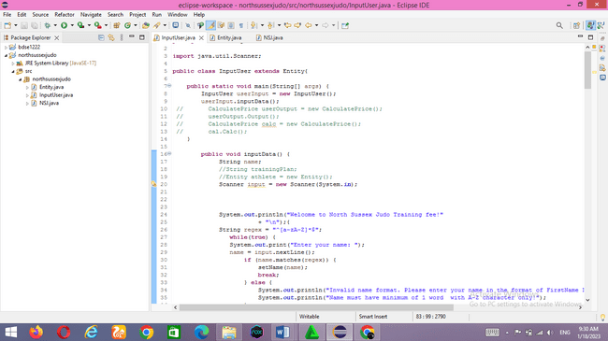

if you need a category with a purpose to inherit from every other magnificence, then you may use "extends" kind extends after the class call after which upload the call of the inheriting magnificence. Then anything is withinside the heir magnificence may be at once accessed through the inheriting magnificence.

Extends key-word in Java The prolonged key-word extends a category and is a hallmark that a category is being inherited through every other magnificence. When you assert InputUser Class extends a Entity class, it method that UserInput class is inheriting the properties(methods, attributes) from Entity class.

Here, Entity Class is the superclass or figure magnificence and InputUser Class is the subclass or infant magnificence.

* Is-A courting IS-A Relationship is finished associated with inheritance.

For example – a kiwi is a fruit; a bulb is a tool. This courting may be done through:

• Using extend Keyword

• To keep away from code redundancy

• IS-A courting is unidirectional, this means that we will say that a bulb is a tool, however vice versa; a tool is a bulb isn't viable seeing that all of the gadgets aren't bulbs

• The IS-A courting is a good couple, which means that converting one entity will have an effect on different en How to obtain IS-A courting

• IS-A courting can surely be done through extending an interface or magnificence through the use of increase key-word entities.

Advantage of IS-A courting :

Code Reusability.

Reduce redundancy.

How to obtain IS-A courting : IS-A courting can surely be done through extending an interface or magnificence through the use of increase key-word.

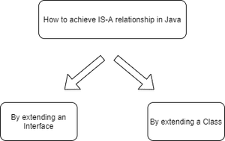

ENTITY CLASS (parent class)

**NSJ (grand Father class)**

InputUser (child class)

In the diagram above, InputUser extends the Object class, which means that Entity is the parent class of InputUser, and InputUser is intended to have an Is-A relationship.

* WORKING EXAMPLE IN THE PROJECT:

This is an object class that inherits its content from the InputUser class

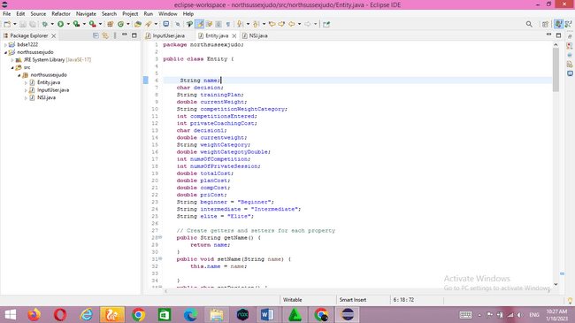

And here is the InputUser class which inherits from the entity class by typing extends

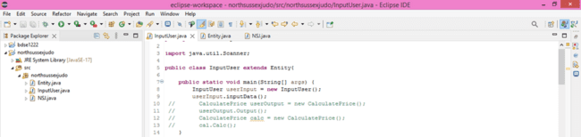

* Java keywords**:** package, static, import, public, class, void, extends, new, while, if, else, break, boolean, int, private, char, double, return, this.

|  |  |
| --- | --- |
| **Keyword** | **Fungsion** |
| package | To define the class Package name |
| static | One of the properties for variables and methods, so that we can call them directly without having to create an object from the class |
| import | Importing packages |
| public | Access rights that allow attributes/data to be accessed by any class, in the same or different packages |
| class | Used to define and implement objects |
| void | Void is a method that does not have a return value, usually it is not used to look up values ​​in an operation |
| extends | Used to inherit the properties of a subclass/parent class on its child subclass/class |
| new | New is used to create an instance of a class or array |
| while | The while keyword is used to loop, as long as the condition is true until the expression evaluates to false |
| if | To make a conditional statement |
| else | A keyword that is used in combination with an if to make a statement if the condition in the if is not met |
| break | Break is used to execute the program to the next command. So, this break keyword skips the statement the programmer doesn't want, and continues on to the next statement |
| boolean | Boolean is used to declare a variable that can store values ​​of type boolean, i.e. true or false |
| int | The data type is an integer, the data type Int has a size of 32 bits and a Range of -2147483648 to.d. 2147483647 |
| private | Access Rights so that the properties of a class cannot be inherited and can only be accessed by the class itself |
| char | Declare a variable that can store a 16 bit character value |
| double | To store fractional values, has a size of 8 bytes and 64 bits and a length of Range +/- 1.8 x 10308 with a total precision/digit of 15 |
| return | To return the value of a variable |
| this | Used to represent an instance of the class in which it appears, or used if a variable name is the same as a parameter |

* JAVA CONTROL STRUCTURES

Decision-Making statements:

As the name suggests, decision statements specify which statements are executed and when. Decision statements evaluate the logical expression and flow of a control program depending on the outcome of a given condition. There are two types of decision statements in Java i.e. if statement and switch statement. In this project I used an if statement.

¬ If Statement: In Java, the "if" statement is used to evaluate a condition. The control of the program is directed depending on the specific situation. The condition of an if statement evaluates to a logical value of true or false.

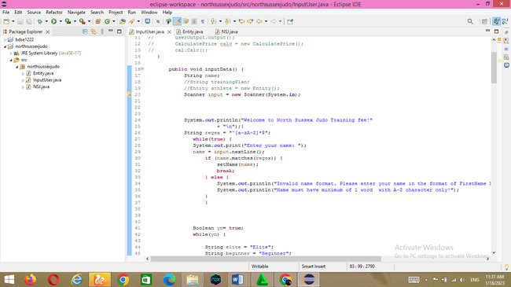

2) Nested if-statement

In nested if-statements, the if statement can contain a **if** or **if-else** statement inside another if or else-if statement.

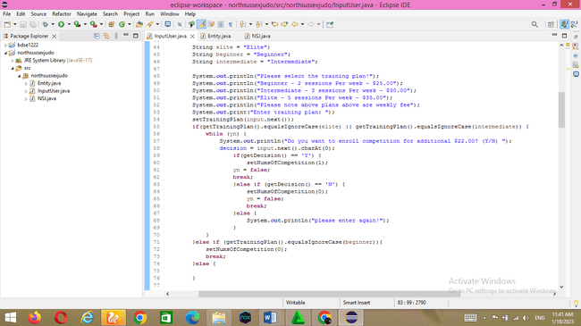

* (JUMP STATEMENT)

Java break statement

As the name suggests, the break statement is used to interrupt the current program flow and transfer control to the next statement outside a loop or switch statement. However, with nested loops, only the inner loop is broken.

Java program cannot use break statement by itself. H. Can only appear inside a loop or switch statement

.



* && (Logical AND)

This operator is used to compare AND conditions. Returns true if both conditions are true. Operators are executed from left to right. Also note that && is a short-circuit operator. The short-circuiting operator here means that if the condition on the left is false, the operation on the right is never executed because the result is definitely false.

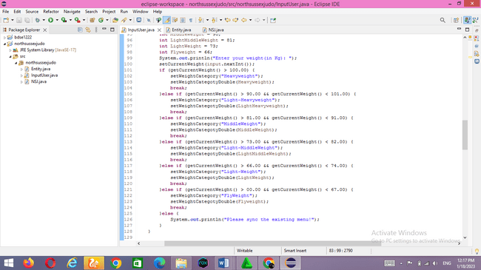

* equalsIgnoreCase()

The equalsIgnoreCase() method is used to compare a string to a specific object, regardless of case.

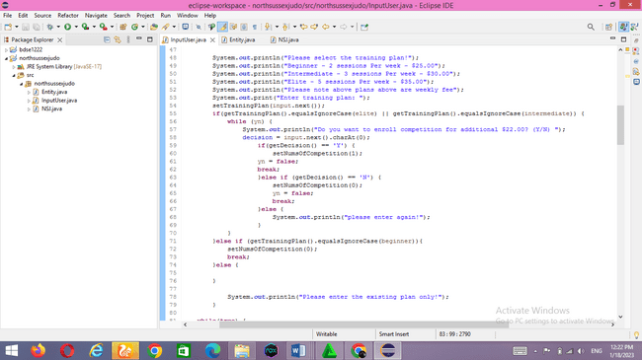

* Coding editor and JDK version installed.

Eclipse IDE for Java Developers - 2022-09 and jdk-11.0.17

* Prepare your project structure.

Different classes structured in their respective packages

Just click new-->package and Eclipse will ask you for the name of the package. Enter the name of the package and you're done.

If you want to create a Java class for this package, select the package in the Package Explorer and create a new -->Java class.

Using packages in Java is very easy. To declare a package in Java, simply use the package keyword and package name at the top of your Java source file. The package declaration must be the first line in the Java source file, before any import statements.

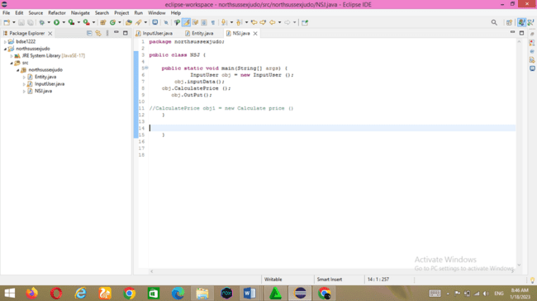

This project has a northsussexjudo directory with packaged NSJ classes. When the Java compiler compiles this class, it will check if this particular class is stored as /north/sussex/judo/NSJ.java relative to the classpath.

All Java classes are structured in separate packages based on their functionality. For example, the java.lang package contains essential classes for the Java programming language. B. Threads, exceptions, errors, objects, etc.

Packages like java.util, on the other hand, contain all the helper classes. Collection classes, scanners and other utilities. The java.io package contains Java classes related to input/output functions. Packages provide encapsulation for Java programs. The default access modifier for variables or classes is package-private. They are visible only in the package in which they are declared.

Use packages to encapsulate all functionality. This allows you to change functionality, including new functionality, or change the implementation without breaking the entire application.

Packages are not the highest level of Java encapsulation that the private keyword can achieve, but they are still the best option and should encapsulate all functionality, not just classes.

Packages are also the primary tool for organizing your code. You have to put a lot of effort into determining package naming, which classes belong to which packages, etc. Also, for better architecture, try following the packaging best practices from Uncle Bob (Robert C. Martin):

1) CCP (Common Closure Principle) - advises merging classes that are likely to change together. Obviously it should be part of the same functionality.

2) CRP (Common Reuse Principle) - advice to set classes based on reusability aspects. Huge packages containing many classes that cannot be reused together are discouraged. The idea is to keep the package small and cohesive.

Most importantly, name your packages appropriately based on their functionality.

.

**TASK 5**

5.1 An explanation of the debugging features available in your chosen IDE.

* Debugging:

Debugging is the process of finding and fixing bugs and errors in software source code. When software doesn't work as expected, computer programmers examine the code to determine the reason for the failure. Debugging can also mean a system that shows the flow of a program, sometimes referred to as a flowchart/process of a running program.

Debugging is the process of finding and eliminating program or system errors. A bug is an error or defect that prevents a program or system from working properly. Programs are usually written with very complicated and complicated code, so a small mistake can have a big impact on the whole program. Therefore, pre- and post-release debugging of your program is very important.

The word debug comes from the word bug, which means insect. The term comes from a rather unique incident. On September 9, 1947, an American computer scientist named Grace Brewster Murray Hopper discovered an insect trapped in his computer's relay. This will prevent your computer from working. After this incident, the word debugging came into general use. In 1945 the word debug was used in aviation. This can be interpreted as testing aircraft engines. Then, in 1963, the term debugging came into common use among programmers to refer to the process of finding and correcting program or system errors. The

* breakpoint is useful for interrupting program execution to which it is applied. A breakpoint is a place in executable code where the operating system stops execution and switches to the debugger. This allows you to analyze your target and issue debugger commands.
* . Watch options become available when you right-click the watch code. Click the Watch button to display the Expression tab. Variables listed in the Expression tab are in scope of the tested method. You are free to create expressions based on the variables contained within the method's scope. If the variable does not exist in the scope of the method, an error will be displayed on the Expressions tab. So when you press the Step Into button that takes you to another method, you get an error because the variables in the formula you created were not recognized.
* Inspect Press Ctrl + Shift + I to see the output of the statement in a popup window. You don't need to save the file to see the output of a particular expression.
* step keys

There are three buttons that I use all the time in the Eclipse IDE. That is, the Step Over, Step Into, and Step Return buttons.

* Step over = easily row by row. However, the step over does not enter the body of the function.
* Step into = entry into a function.
* step return = step into function, opposite of step out
  1. Explain briefly the steps involved in debugging the developed application, along with screen captures.

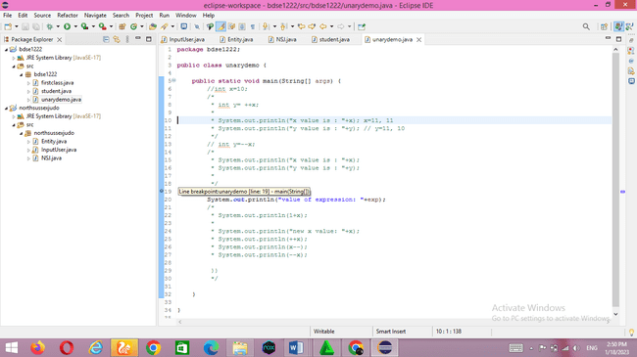.First, we need to create a breakpoint. Breakpoints here are useful to set where debugging starts/starts (not where the application starts, but where the programming process starts reading occurs. Debugging can be placed in the middle of the application ). To make it very easy, click twice (twice) to the left of the line number to display a dot as shown below.

Second, open the debug properties to display the debug functions window so that we can find out what is actually running when we run the application we created

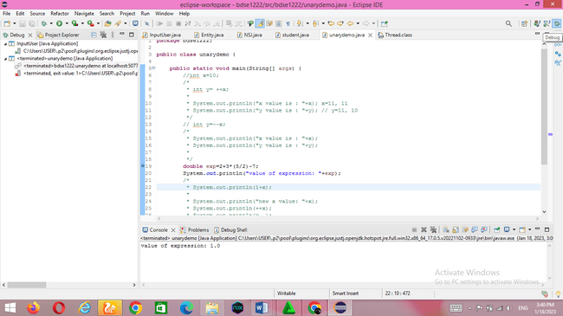

Select Debug Properties and you will get a layout similar to the image below. To return to normal, you can repeat the second step

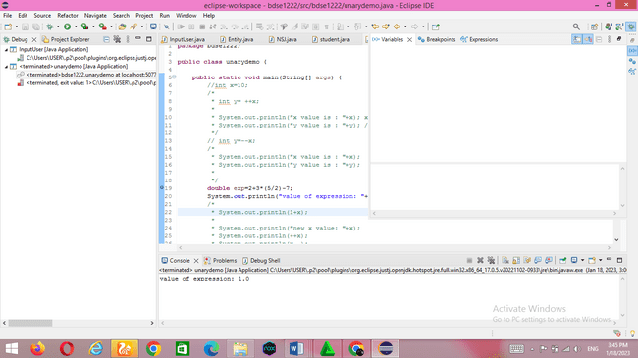

Third, start debugging by pressing the button as shown below

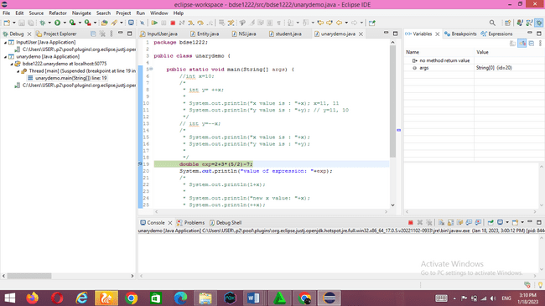

After that a debug will appear as below

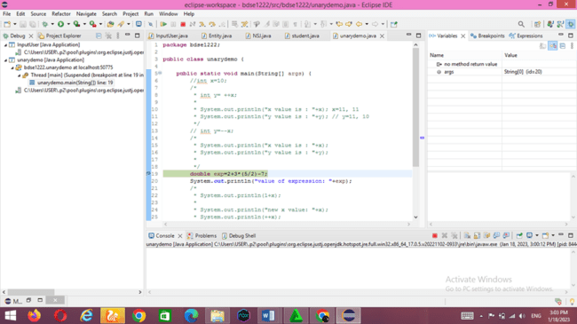

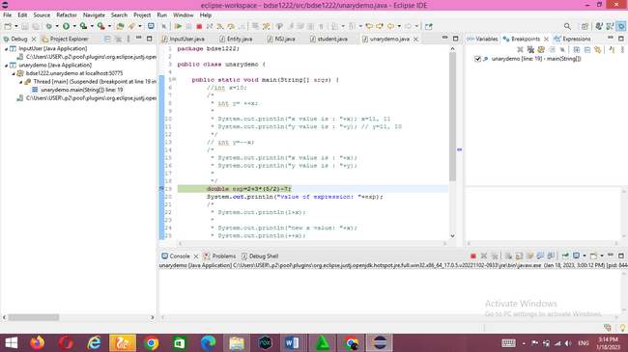

Fourth, click Step Over. simply line by line. However, the step over does not enter the body of the function. The Step Over button provides another way to step through your app's code at runtime. This code moves execution to the next line of code and speeds up the debugger

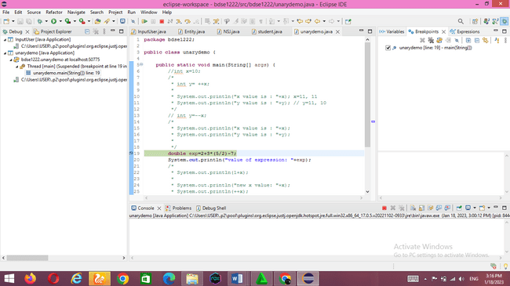

The result text below will come out, then click step over again.

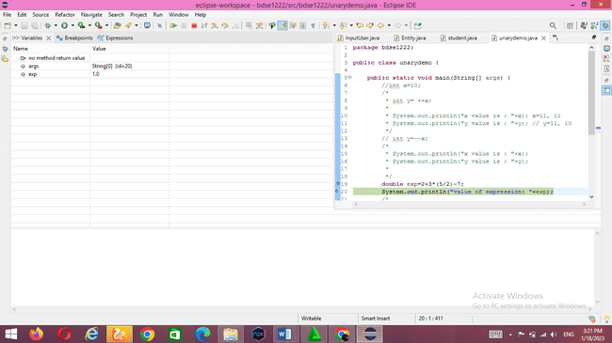

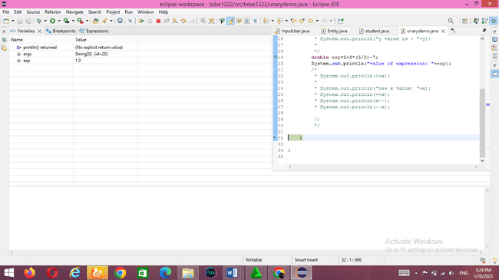

After clicking again, the next result will appear

Click step into then it will enter into the function as shown below :

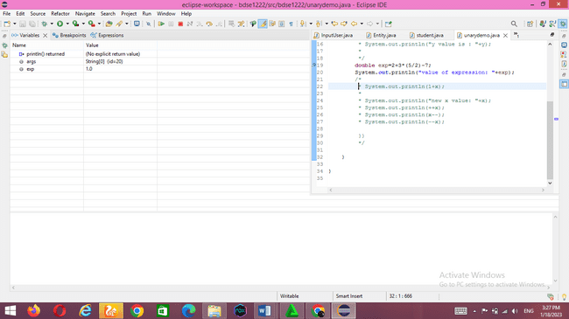

Click stop to end it

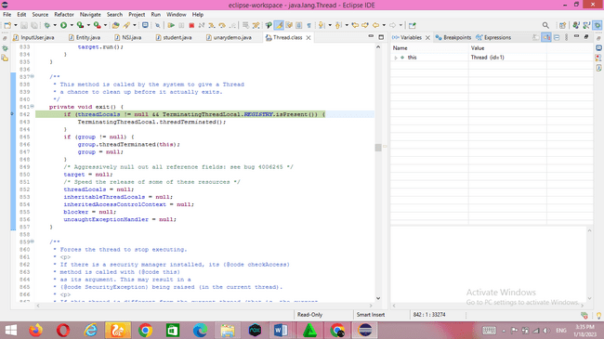

TASK 6

a.Software development process SDLC approach :

Project request, gathering i/p, output n process For beginning request approach to SDLC :

we will introduce my company which is my company is AQDS name. My name is Syavira Rizki Ariani,I just started a new role as a Junior Software Developer at a AQ Digital Solutions (AQDS). AQDS are independent software develop team as a software solution of all sizes and variety industries.

AQDS (AQ Digital Solutions) company has been approached by a small (Local Company) it is North Sussex Judo that specializes which providing training sessions to members of the local community. Regardless from of their level of experience.they cater to people of all ages and skill levels (expert to beginner), and committed to provide high quality judo training for the people who has interested for it. North Sussex Judo Company, their has make a strong to built a local community which is the North Sussex Judo it self has a loyal for the costumer base of people who had interested about the judo and always for comitte to improve their skills and abilities.

As a Result from approach the North Sussex Judo And we are as a junior software developer from AQDS so interested to potentially work with north sussex judo and making a solutions and their goals by developing costumized software solutions.

We need help or we will request to SDLC to making program high quality gathering to purpose reach the customer goals , we know SDLC works by lowering the cost of software development while simultaneously improving quality and shortening production time. And SDLC achieves these apparently divergent goals by following plan that removes the typical pitfalls of software development projects.That plan starts by evaluating existing systems for deficiencies. We must define it’s the requirements of the new system. It then creates the software through the stages of analysis, planning, design, development,testing, and deployment by anticipating costly mistakes like failing to ask the end user or client feedback,that SDLC can eliminate redundant rework and after thefact fixes.And also important to know what there is a strong focus on the testing phase. We have to ensure code quality at every cycle. Following the best practices and or stages of SDLC ensures the process work in smooth, efficient, and produktif way.

Input/ output process :

Identify current problems:

We need to identify and get feedback from all suppliers including customers, industry experts, etc., learn the strengths and weaknesses of the current system with the goal of improvement.

Plan

The team determines the costs and resources needed to fulfill the analyzed requirements. It also details the risks involved and provides sub-plans to mitigate the risks.

Design

Start by turning the software specification into a detailed blueprint known as a design specification. It is crucial to have a plan in place to gather and incorporate stakeholder input into this document and failure to do so at this stage will almost certainly result in cost overruns at best and The worst is the complete collapse of the project.

Build

At this point, the real development begins. It is important for each developer to stick to the agreed-upon view. And also make sure you have the right guidelines for code style and practices.

code check

We check for errors and defects. We deal with these until the product meets the original specifications.

software deployment

The goal is to deploy the software into a production environment so that users can start using the product. However, many organizations choose to move the product to different deployment environments, such as testing/staging environments.

operation stages

The exploit phase involves using the software in production development

monitoring phase

Various elements of the software are monitored. These may include overall system performance, user experience, new security holes, breakdown or failure in the system. A plan is almost never perfect when it meets reality. Also, as real-world conditions change, we need to update and develop the software accordingly.

The DevOps movement has changed SDLC in a number of ways. Developers are now responsible for more and more stages of the entire development process. We also see the value of moving left. When development and operations teams use the same set of tools to monitor performance and identify errors from application creation to deletion, it provides a common language and faster handoff between teams.

b. Problem solution design.:

Sometimes a designer will come across a situation where there is a general problem, but not a specific problem that needs to be fixed. One way to help designers clearly define and describe a problem is to create human-centered problem statements.

A problem statement helps define an issue in a way that provides relevant context in a way that is easy to understand. The main purpose of the problem statement is to guide designers to find possible solutions to the problem. A problem statement shapes the issue in a way that easily highlights the gap between the current state of affairs and the end goal. Designers generate potential solutions to the problem described in the problem statement. Use brainstorming techniques with the team to identify and then a human-centered solution to the identified problem. Here are some brainstorming strategies we can use with your team to come up with solutions:

• Standard brainstorming session:

groups gather and discuss out loud different ideas.

• Brain writing:

People write their ideas on a piece of paper or stick them on paper and each team member writes their ideas on the whiteboard.

• The worst possible idea:

Contrast with the end goal. The team produces the craziest idea so that no one looks stupid. This eliminates the rigidity of other brainstorming techniques. This technique also helps you identify areas where you can improve in your actual solution by looking at the worst parts of a pointless solution.

In the prototype phase, you and your team design a few different variations of low-cost or scaled-down versions of the potential solution to the problem. Having different versions of your prototype gives your team the opportunity to test solutions and improvements. Prototypes are often tested by other designers, team members outside of the original design department, and trusted clients or members of the target audience. During this process, it is important to document the testers using the final product. This will give you valuable insight into which parts of the solution are good and which need further editing. During this process, it is important to document the testers using the final product. This will give you valuable insight into which parts of the solution are good and which need further editing. Test

After testing different prototypes with trailers, your team should have different solutions to improve their product. The testing and prototyping phase is an iterative process, so much so that some design projects may never end.

When designers have taken the time to test, iterate, and redesign new products, they can find new problems, different solutions, and better understand the end user.

c. IDE for development + language +OOP :

We can use any text editor to write code. However, most integrated development environments (IDEs) have more functionality than text editing. IDEs provide a central interface to common developer tools, thereby making the software development process much more efficient. Developers can quickly start programming new applications instead of manually integrating and configuring disparate software. Developers also don't need to learn all the tools and focus more on just one app.

We can find many modern integrated development environments (IDEs) on the project with different features and different price levels. Many IDEs are either open source or free to use and configure. Here are some criteria to consider when choosing an IDE:

**Programming language**

The programming language you wish to code in will often dictate your choice of IDE. Dedicated IDEs have automation features that specifically conform to specific language syntax. On the other hand, a multi-language IDE supports multiple languages.

For the programming language more than easier we used the oops

For the project :

Object-oriented programming

The idea of objects, which are data structures that contain data in the form of fields (or attributes) and code in the form of procedures, serves as the foundation for the programming paradigm known as object-oriented programming (OOP) (or methods). A defining characteristic of objects is that an object's procedures grant access to and modify its fields.

Computer programmes are created using objects that communicate with one another in object-oriented programming. Although there is a lot of variety in object-oriented programming, the majority of widely used programming languages are class-based, which means that objects are instances of classes, and classes usually also provide the type of an object.

Procedural programming evolved into object orientation. Other procedures, usually called routines, subroutines, or methods, provide the actions that must be taken during computing.

Any specified procedure may be invoked at any time while a programme runs, either by itself or other processes. A list or collection of instructions known as procedural programming tells a computer exactly what to do, step by step, and how to go from one code to the next. C, Fortran, Pascal, and BASIC are examples of procedural programming languages.

In contrast to object-oriented programming, which focuses on breaking down programming tasks into objects that expose behavior (methods) and data (fields) using interfaces, procedural programming focuses on breaking programming tasks down into a collection of variables, data structures, and subroutines. The most significant difference is that object-oriented programming combines procedures and data structures such that each object, which is an instance of a class, can operate on its "own" data structure, as opposed to procedural programming, which utilizes procedures to operate on data structures.

Advantages Of Object-Oriented Programming :

* + - * + Particularity: Epitome enables items to act naturally enclosed, simplifying research and group improvement.
        + Reusability: Because legacy allows for code reuse, a team doesn't have to create the same code repeatedly.
        + Usefulness: Using various libraries and reusable code, developers may quickly create new applications.
        + Effectively upgradable and versatile: Developers can use the framework's features freely.
        + Interface depictions: Because message passing techniques are used for object communication, depictions of external frameworks are simple.
        + Security: Extensive code is concealed, programming support is made simpler, and web norms are secured through exemplification and consideration.
        + Adaptability: A single capacity can adapt to the class it is set in, thanks to polymorphism. A similar interface can be used for many topics.

Operating system

While most IDEs have multiple versions for different operating systems, they may work better on certain platforms. For example, some IDEs may work better on Linux platforms, but may be slow or difficult to use on others.

Automation function

Three features common to most IDEs are the source code editor, build automation, and debugger. Additional features may vary and may include the following:

• Improved code editor user interface

• Automated testing features

• Code deployment support through plugin integration

• Restructuring support

• Application packaging support

Customize IDE

Some IDEs have the ability to customize workloads based on developer needs and preferences. You can download and use plug-ins, extensions, and plug-ins to customize your programming experience.

d. Project create/edit window to generate java classes + console/debug window to test and understand.

Here are the IDE components to build and run the project. And that explains why IDEs matter:

* + Automate code editing

Programming languages ​​have rules for how to structure instructions. Since the IDE knows these rules, it has many smart features to automatically write or modify the source code.

* + Syntax highlighting

The IDE can format text by automatically bolding or italicizing certain words or using a different font color. These visual flags make source code easier to read and provide quick feedback on unintended syntax errors.

* + Enter the smart code

Various search terms will appear when you start typing words into the search engine. Likewise, the IDE can provide suggestions for completing code instructions as the developer begins typing.

* + support refactoring

Refactoring is the process of refactoring source code to make it more efficient and readable without changing its core functionality. IDEs are auto-refactoring to some extent, allowing developers to improve their code quickly and easily. Other team members can understand readable code faster, which will promote team collaboration.

* + Local build automation

IDEs increase programmer productivity by performing repeatable development tasks that are often part of every code change. Here are some examples of common coding tasks performed by IDEs.

* + Compilation

The IDE compiles or converts the code into a simple language that the operating system can understand. Some programming languages ​​implement just-in-time compilation, where the IDE converts human-readable code into machine code from the application.

* + Experiment

IDEs allow developers to automate unit testing locally before the software is integrated into another developer's code and run more complex integration tests.

* + Bracket:

Supports simple debugging of any system.out and system.out redirects. Error in console window

* + Console

is a simple debugging aid that redirects any System. out and System. err to the console window

* + debugging

Debugging is the process of fixing bugs or errors caused by testing. One of the greatest merits of an IDE for debugging purposes is that you can step through the code line by line as it runs and examine the behavior of the code. The IDE also incorporates a number of debugging tools that highlight errors caused by human error in real time, even as the developer is typing.

e. Explain use JRE and JVM :

JRE (Java Runtime Environment) is an installation package that provides an environment to run (and not develop) only Java programs (or applications) on your machine. JRE is only used by people who only want to run Java programs as end users of your system.

1. Deployment technology, including deployment, Java Web Start, and Java Plug-in.

2. The UI toolkit includes Abstract Windowing Toolkit (AWT), Swing, Java 2D, Accessibility, Image I/O, Print Services, Audio, drag and drop (DnD), and input methods.

3. Built-in libraries include Interface Definition Language (IDL), Java Database Connectivity (JDBC), Java Naming and Directory Interface (JNDI), Remote Method Invocation (RMI) , Remote method calling over Internet Inter-orbital Protocol (RMI -IIOP), and scripting.

4. Other core libraries include international support, Input/Output (I/O), Extension Mechanics, Beans, Java Management Extensions (JMX), Java Native Interface (JNI) ), math, networking, substitution, security, serialization, and Java for XML processing (XML JAXP).

5. lang and util core libraries include lang and util, manager, versioning, zip, tools, reflection, Collections, Concurrency, Java Archive (JAR), Logging, Optional API, Object Reference, and Regular Expression.

6. Java Virtual Machine (JVM), including HotSpot Java Client and Server Virtual Machine.

JVM (Java Virtual Machine) is a very important part of JDK and JRE as it is contained or integrated in both. Any Java program you run using the JRE or JDK goes into the JVM, and the JVM is responsible for executing the Java program line by line. Therefore, it is also known as an interpreter.

which stands out from the java virtual machine. It is as follows:

• A specification where Java Virtual Machine operation is specified. But the implementation vendor is independent to choose the algorithm. It is made by Sun and other companies. • An implementation is a computer program that meets the requirements of the JVM specification.

• Executing instance Whenever you write a java command on the command prompt to execute the java class, an instance of the JVM is created.

6.2

Screen Capture of project structure :

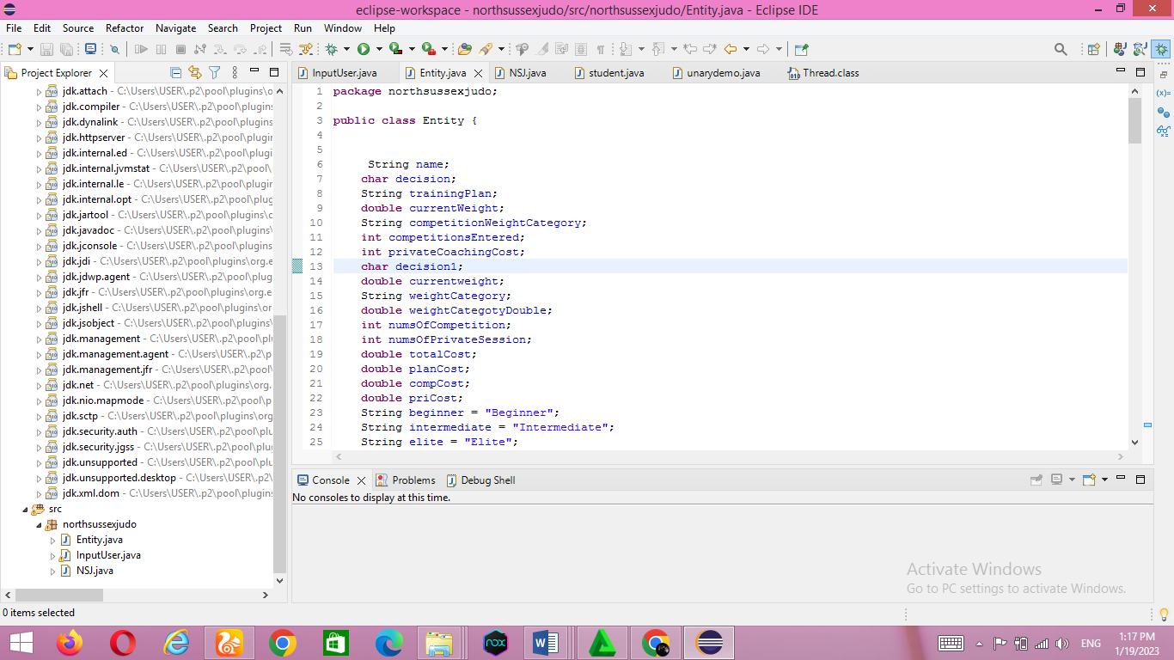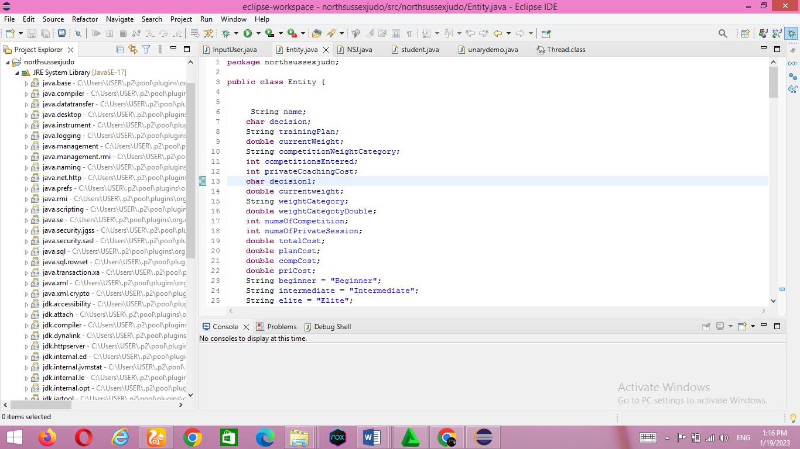

Text editors

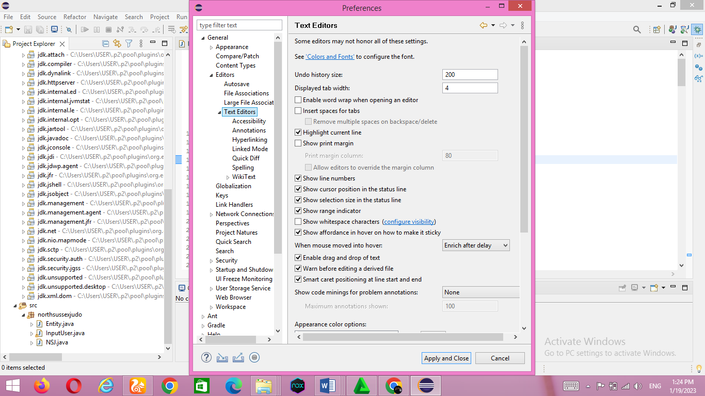

Console

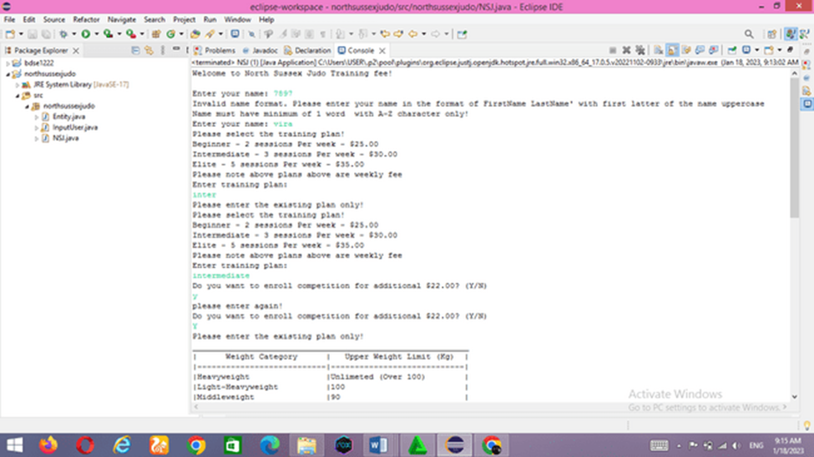

Debugging :

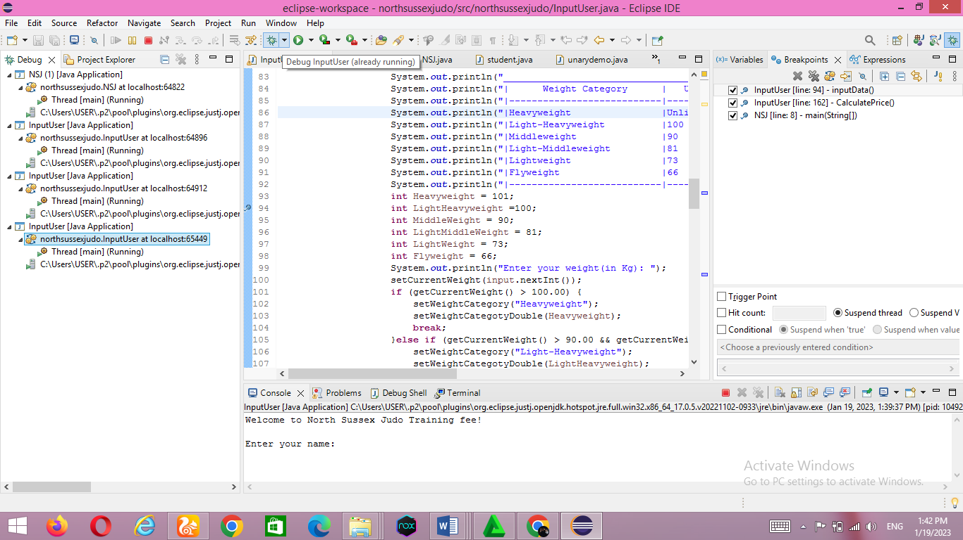

TASK 7.

7.1 Coding Standards

**Coding Standards for Methods:**Usually method name should either be verb or verb noun combination starting with lower letter. If it contains multiple word than every inner word should start with uppercase.

Example: ()

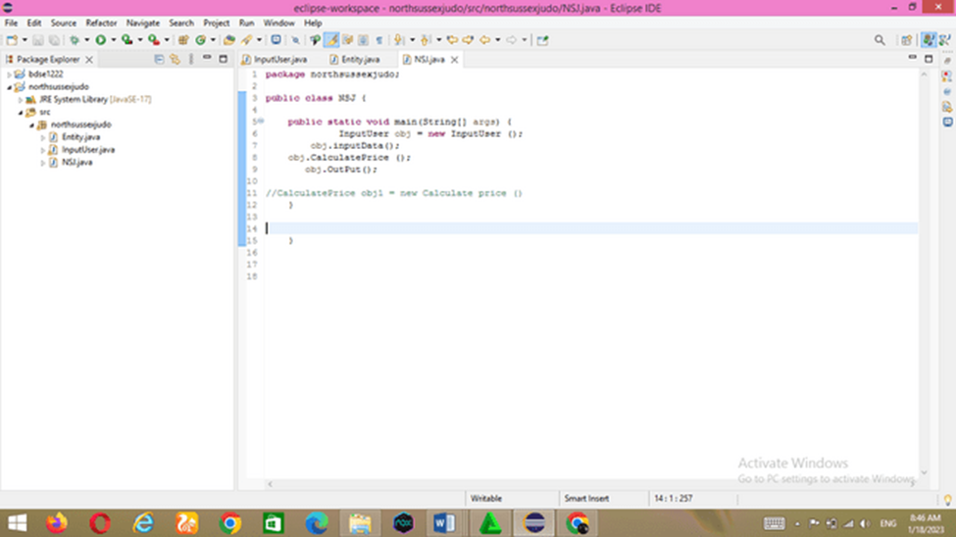

Java Bean coding standards :  A Java Bean is a simple java class with public getter and setter methods

**Getter Methods:**

1. It should be public method
2. Method name should be prefixed with “get”
3. It should not take any argument

**Setter Methods:**

1. It should be public method
2. Return Type should be void
3. Method name should be prefixed with “set”
4. It should take some argument

Example :

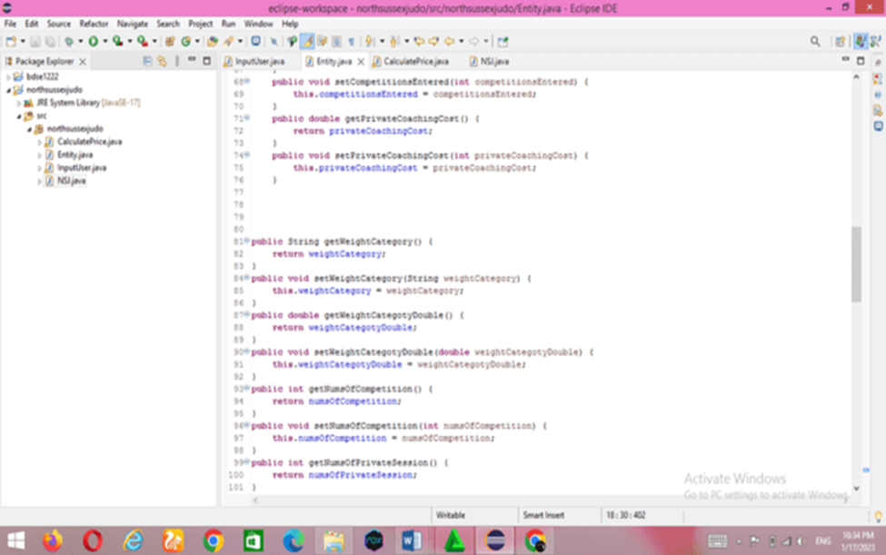

**Class Members must be accessed privately**

It is considered a good Java practice to keep the accessibility of class fields as inaccessible as possible. It is made to protect the fields. To achieve this, the private access modifier is the ideal choice. This practice is recommended to maintain encapsulation, one of the basic concepts of OOP. Although this is an extremely basic concept of object-oriented programming, many programmers who are new to it still do not properly assign class access modifiers and prefer to make it public for ease of use. understand**.**

Consider this class where fields are made public:

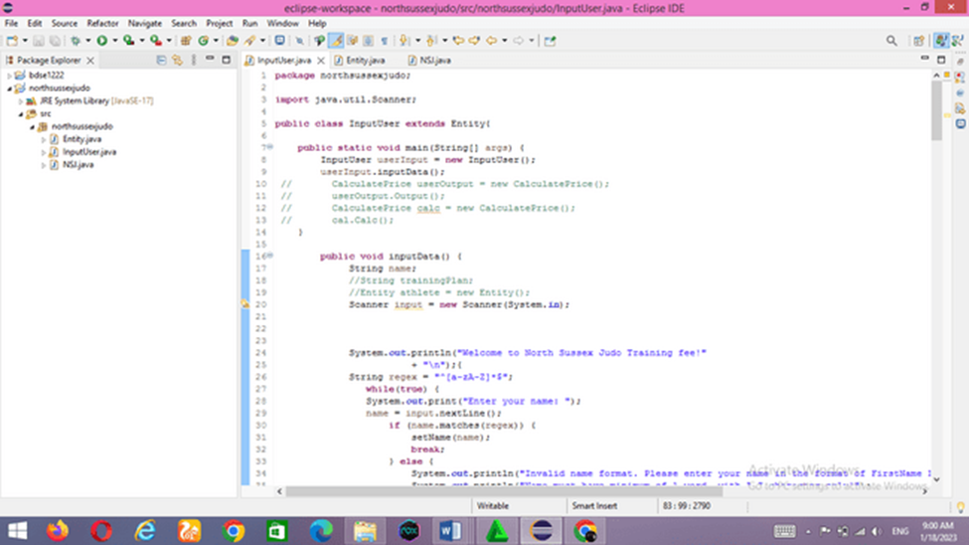

6. Strings

No other type in Java is as extended as String. Java strings are represented in UTF-16/other formats and are immutable objects. This means that every time we perform an operation such as concatenation, which requires modification of the original string, a new string object is created. This intermediate string object, created just to perform the necessary operation, is useless and inefficient. This is because creating intermediate objects is not necessary; it involves garbage collection, although we can avoid it. There are two related string classes, called StringBuffer and StringBuilder, that can support the kind of string manipulation we might need. These two classes are made for that. The only difference between StringBuffer and StringBuilder is that the former is thread-safe. We can use these two classes whenever we need to manipulate extended strings rather than using immutable String object.



BOXING & UNBOXING

In Java, canning and unboxing are the reverse of the same technique called conversion between primitive types and their respective wrapper classes. Wrapper classes are nothing but "class" versions of primitive types like int to Integer, float to Float, double to Double, char to Character, byte to Byte, Boolean to Boolean, etc. Boxing converts, for example, an int to an integer, and unwrapping returns an Integer to an int. Compilers usually do the conversion behind the scenes; this is called autoboxing. However, sometimes this automated mailbox can produce unexpected results and we should be aware of that.Bxing and Unboxing

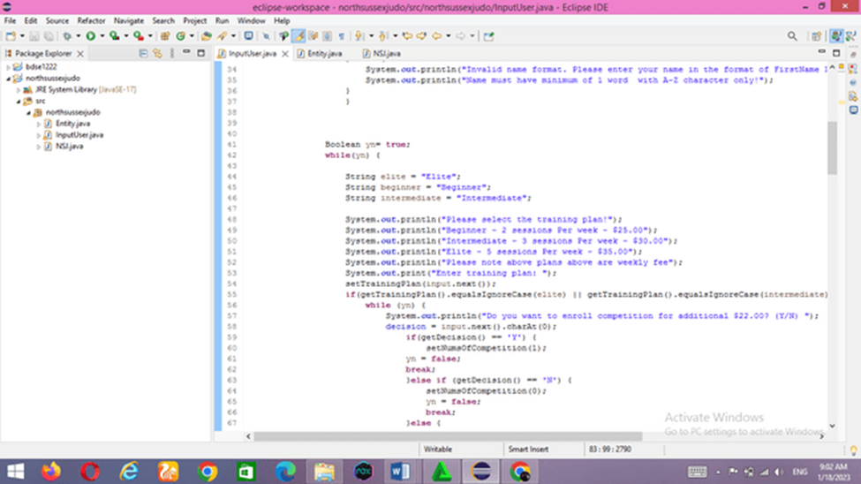

Reference :

<https://careerkarma.com/blog/object-oriented-languages/#:~:text=Java%2C%20Python%2C%20C%2B%2B%2C,programming%20languages%20in%20the%20world>.

<https://www.geeksforgeeks.org/computer-science-projects/?ref=sh>

<https://benchpartner.com/advantages-and-disadvantages-of-event-driven-programming>

<https://www.petanikode.com/java-windows/>

[**https://docs.gradle.org/current/userguide/building_java_projects.html**](https://docs.gradle.org/current/userguide/building_java_projects.html)

[**https://data-flair.training/blogs/java-virtual-machine-jvm/**](https://data-flair.training/blogs/java-virtual-machine-jvm/)

<https://www.geeksforgeeks.org/introduction-to-algorithms/>

<https://www.developer.com/design/top-10-java-coding-guidelines/>

<https://www.geeksforgeeks.org/jvm-works-jvm-architecture/>

<https://stackoverflow.com/questions/56168640/howto-do-project-structure-src-main-java-in-eclipse>

/